NEW MPA POLICY: PANACEA, OR TALK FEST? Dive NZ Feb 06

by Roger Grace

So the Government has rolled out its new policy and implementation plan for Marine Protected Areas. A new unholy alliance between the Ministry of Fisheries and the Department of Conservation has been cooked up with a view to seeking a completely open and transparent process for protecting chunks of the sea and oceans around New Zealand, from the foreshore out to the 200-mile limit of the EEZ.

The MPA Policy objective is to: "Protect marine biodiversity by establishing a network of MPAs that is comprehensive and representative of New Zealand's marine habitats and ecosystems".

The Policy and its summary brochure outlines an implementation plan telling us how the Policy will be actioned. First marine habitats and ecosystems around NZ will be classified based on the best scientific information available. An inventory will be taken of existing marine areas that have some level of protection, and the extent to which those areas cover representative habitats and ecosystems will be assessed. The "protection standard" will be used to determine which of these areas have sufficient protection to be designated as MPAs, and where gaps in the MPA network exist. Then habitats and ecosystems which are under-represented will be prioritised for new MPAs.

The Government intends that at least one example of each habitat or ecosystem within each bioregion will be protected by a marine reserve. In other words fully no-take marine reserves will be used to protect representative examples of the full range of marine communities and ecosystems that are common or widespread, as well as examples that are outstanding, rare, distinctive, or internationally or nationally important.

The MPA Policy is definitely a step in the right direction, when we compare it with what we had before. As mentioned in the foreword to the policy document, in the past the approach to marine protection has been fragmented. The MPA Policy does much better. It provides an integrated process, including regional consultation, for establishing a network of marine protected areas around New Zealand, to protect marine biodiversity.

Planning for offshore MPAs will be implemented at a National level, whereas planning for nearshore MPAs will be implemented at a regional level. Both processes will provide opportunities for constructive engagement with tangata whenua, user groups, and the public, and will minimise the adverse impacts of new MPAs on existing users.

There are several rather worrying aspects to the new Policy document, however. It still basically assumes that nothing will be "protected" until there is evidence of actual or potential damage. Considering that all of New Zealand's seas have some protection now, in the form of marine mammal protection and the Quota Management System for fisheries, as well as a whole raft of fishery regulations applied to recreational fishers, it will be tempting to assume for most areas that what we have now is adequate protection.

When we consider that fisheries policy is to deliberately exterminate about 80% of the population of each quota species in the interests of achieving the maximum sustainable yield (MSY) then it is obvious that nearly all of the sea is already under severe stress and threat. You can't take out 80% of the top predators without having significant impacts on the rest of the ecology and biodiversity. So there is a case which can be made for protection, anywhere, because fishing policy is applied, everywhere.

Despite the indication in the policy document that the classification system part of the process will be completed by June 2006, agreement on the classification of habitats and ecosystems and its application in the various bioregions will be difficult and open to opinions. Potential for lengthy delays is high.

What will be crucial to a successful outcome from the new MPA Policy will be a definition and interpretation of the Protection Standards which will be applied. To meet the protection standard, "a management tool must enable the maintenance or recovery of the site's biological diversity at the habitat and ecosystem level to a healthy functioning state." To my mind the only protection standard which achieves this statement is total protection in a marine reserve. Within the MPA Policy document, however, there is a continuing insistence on a spectrum of levels of protection, while ignoring the need to establish a sustainable system of highly-protected marine reserves. No-take marine reserves are the only practical way of ensuring the protection of biodiversity "in a healthy functioning state".

Dicking around with any less protection than total protection, in order to appease a minority of the population who insist on their "right" to fish everywhere, will require a huge amount of research effort in order to assess the impacts of whatever reduced amount of fishing is decided upon as appropriate in each particular case. If you kick out the commercial fishers, and reduce the amateur catch to one snapper per day, for example, how will you know if this is working to help protect biodiversity? The only way is to carry out a research project which, to tell you the answers, would have to be long term and comprehensive, and very expensive.

MinFish can't afford to do enough research on the quota species now in order to get their QMS right - big mistakes are frequent - so what hope is there of sufficient funding to carry out research in all the little partly protected MPA's scattered around the coast which might result from the new policy?

The only thing we know that works is total protection in a marine reserve. That is the maximum protection possible, and should be what we concentrate on. We can't provide better protection than that. It does not require lots of monitoring and management feedback. We know it gives the best chance possible for marine biodiversity recovery and long-term maintenance. No other level of protection can give that guarantee. Other levels of MPA's will gobble up time and effort, for very little effect when it comes to biodiversity protection. MPA really stands for "Much Pissing About", whereas Marine Reserve (MR) stands for "Maximum Result".

When it comes to the time for public input at a regional level, it is very important that the wider public gets heavily involved in this process. Early last year WWF conducted an opinion poll that found 95% of New Zealanders wanted more Marine Reserves. Soon it will be time for those people to stand up and be counted, and make sure that the network of MPAs really concentrates on the important network of no-take Marine Reserves.

Roger Grace
23 February 2006
1077 words
For Dive New Zealand magazine, April-May 2006 issue

CAPTIONS:



1. Planning for offshore MPAs will be implemented at a National level, but will provide for input from user groups, tangata whenua, and the general public.

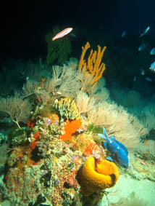

2. No-take marine reserves will protect representative examples of ecosystems, including those that are "outstanding, rare, or distinctive". The Three Kings, with its distinctive marine life and high degree of endemism, must be an obvious candidate for a Marine Reserve.

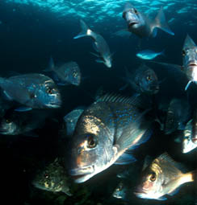

3. Fisheries policy is to exterminate 80% of the population of most quota species in order to achieve the maximum sustainable yield (MSY). Imagine this scene with only two snapper. That is what fisheries policy attempts to do to the whole population.

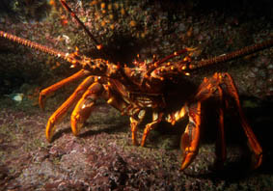

4. Large individuals are very important to breeding success of crayfish. No-take areas are needed to restore the natural age structure of crayfish populations, which will also help restore natural biodiversity of the reefs.

