Proposal to create a Marine Reserve in the area of Ngã Motu, Taranaki.
Draft document for discussion.

Site ‘Option 7’, the area between Paritutu Rock,
and the Tapuae Stream.

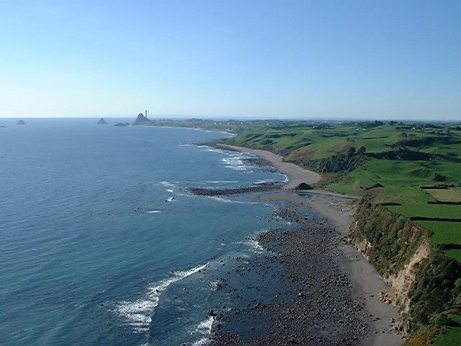
Ngã Motu Marine Reserve Society Incorporated
September 2001
INDEX

Page

2 - 3

4

5

6
6

6
6

7
7
7
7
7

8
8
8
9
9
10
11
11- 12
12
12
13 -14
15
16

17
17
17 -18
19 - 20
20
21
21
21
22
22
22
23
23
23

Section Description

Index

Purpose Of This Document

Please Tell Us What You Think

1. Introduction
  - Draft Of Application For A Marine Reserve Between Paritutu Rock and The Tapuae Stream, New Plymouth.
  - Purpose of Marine Reserves
  - Process For Establishing a Marine Reserve

2. The Application (under discussion)
  - The Applicants
  - The Name
  - Boundaries
  - Objective

3. Background To The Application
3.1 Origin of the Proposal
3.1.1 Ngã Motu Marine Reserve Society Incorporated
3.1.2 The New Zealand Biodiversity Strategy
3.1.3 Setting Course For a Sustainable Future
3.2 Investigation Process
3.3 Research and Studies
3.3.1 Existing Surveys And Publications
3.3.2 Associated publications utilised, and of interest to those proposing marine reserves.
3.3.3 Further Surveys
3.4 Issues Raised In Public Consultation
3.5 Issues Raised By Tangata Whenua
3.6 Boundary Selection

4. Values Of The Proposed Marine Reserve
4.1 Natural Values
    - Habitat Types
    - Marine Life
    - Water Quality
  - Cultural Values
    - Maori Historical Values
    - European Historical Values
  - Amenity Values
    - Landscape / Seascape Values
    - Recreational Values
4.3.3 Educational and Scientific Values
  - Commercial Values
  - Impacts of Human Activity

24
24
24
25
25
25
26
26
27

28
28
28
28
29
29
29

30
30
30
30
30
30
30
31

32 - 33

5 Justification
5.1 Meets The Purposes Of The Marine Reserves Act 1971
    - Of Distinctive Quality: SLIMPA area
    - Typical Taranaki Coast: Herekawa Stream to the Tapuae Stream.
    - The Area will be a Valuable Site for Scientific Study.
5.2 Meets other legislative requirements
5.3 There is community support for the proposed marine reserve.
5.4 Regard For Treaty Of Waitangi
  - A Marine Reserve Builds on and Strengthens the SLIMPA.

6 Implications For Existing And Future Users
6.1 Adjoining Landowners
  - Commercial Operations
  - Recreational Fishing
  - Customary Fishing
  - Scientific And Educational Users
  - Implications For Marine Life

7 Proposed Management
  - Level Of Protection
  - Public Access, Navigation And Anchoring
7.3 Boundary Identification
7.4 Compliance And Law Enforcement
  - Monitoring And Scientific Research
  - Education And Interpretation
7.7 Committee

References and Appended documents

Kia ora tonu te mauri o te moana mo ake tonu.

To maintain and enhance
the life force of the sea for ever.

PURPOSE OF THIS DOCUMENT

This document outlines a draft proposal for a marine reserve from Paritutu Rock to the Tapuae Stream and including Waikaranga / Seal Rocks. It is an amended version of the original discussions to set aside a marine reserve for the SLIMPA area only. It takes into account the views expressed during consultations from October 1997 – August 2001.
This document seeks further submissions and comments on the amended proposal in order to incorporate these, where practicable, into any application for a marine reserve under the Marine Reserves Act 1971.
The Ngã Motu Marine Reserve Society is interested in receiving further comments on the draft proposal from as many individuals, groups, or associations as possible before finally proceeding with a formal application to the Director-General of Conservation. This will require formal public notification and a call for submissions from interested people before the Minister of Conservation makes a final decision on the application.
We acknowledge the assistance of the many families who have given generously of their time, skills and patience in the preparation of this discussion document.

PLEASE TELL US WHAT YOU THINK

Your opinions will influence the final proposal, to be published in early 2002.

- Write a letter to oppose or support the proposal.
Or
- complete the response form attached by October 31st 2001.

Copies of this proposal are available at District Libraries, N.P.D.C. Chambers, Taranaki Regional Council, DOC Devon Street, and ‘New Plymouth Sportsfishing and Underwater Club’.
If you would like further information, a copy of the video Taranaki Coastal and Marine Life, or copies of the pamphlet ‘Ngã Motu Taranaki, Coastal and Marine Life’, or additional copies of this proposal, please contact

‘Ngã Motu Marine Reserve Discussion’
^{c}/_{o} Post Shop Counter
Egmont Village.
- - - - - - - - - - - - - - - - - - - - - - - - - - - - - - -- - - - - - - - - - - - - - - - - - - - - - - - - - -

I support the proposal for these reasons…...

I do not support the proposal and make the following suggestions…...

I use the area for…...

I represent…...
Name…..
Address…...
Please notify me of any meetings to discuss a marine reserve. 
1. INTRODUCTION

1.1 DRAFT of APPLICATION FOR A MARINE RESERVE BETWEEN PARITUTU ROCK AND THE TAPUAE STREAM, NEW PLYMOUTH.

1.2 PURPOSE OF MARINE RESERVES
Section 3 of the Marine Reserves Act 1971 establishes the general purpose of marine reserves as the preservation, for the scientific study of marine life, areas that contain underwater scenery, natural features, or marine life, of such distinctive quality, or so typical, or beautiful, or unique, that their continued preservation is in the national interest.
There are however a number of important benefits that accrue from marine reserves besides their value for scientific study. These include:
- expanded opportunities for education, recreation and tourism;
- the provision of secure refuges for exploited fish stocks and other marine organisms
- the provision of ecological benchmarks against which to assess the impacts of human use and the effectiveness of management systems on the adjacent marine areas.
- being part of a network of small marine reserves on New Zealand’s coast that is representative of all major ecological types.
- The fundamental principle for this Marine Reserve will be to create an area undisturbed by human activity, so that natural processes will be observed.

There is one marine reserve on the west coast of New Zealand North Island, Kapiti.
Parininihi Marine Reserve, in North Taranaki, was proposed in 1995, but has not yet proceeded.
There is a need to represent the ecology of the exposed West Coast/Taranaki Bight in a marine reserve on this coast.

1.3 PROCESS FOR ESTABLISHING A MARINE RESERVE
Marine reserves are established by an Order-in-Council made by the Governor-General following the process set out in Section 5 of the Marine Reserves Act 1971. ₁

2. THE APPLICATION (under discussion)
  - THE APPLICANTS
(It is the wish of the Ngã Motu Marine Reserve Society Incorporated to include tangata whenua in a joint application. However, at this date, the sole applicant for the proposed Ngã Motu Marine Reserve is the Ngã Motu Marine Reserve Society Incorporated.)
The Rules of the Incorporated Society state its Objectives as:
- To establish a network of marine reserves in the Taranaki Region.
- To ensure the marine life and other natural resources within the region are protected.
- To encourage the scientific study of marine life on the Taranaki coast.
- To foster community awareness of the coastal environment by education.

2.2 THE NAME
The name of the proposed marine reserve is Ngã Motu Marine Reserve. It means ‘The Islands’ and is the name used by the tangata whenua of the area, before Captain Cook named it ‘Sugar Loaf Islands’.

2.3 BOUNDARIES
Boundary Selection
Boundary selection has been based on the findings of the “SLIMPA Conservation Management Plan” and the “Proposed South West Extension Report”_{2, 3.}
Consultation and subsequent compromise mean the Northern boundary now excludes the Outer Islands of Moturoa and Ngã Mahanga (Saddleback). However, the boundaries still include representative examples of all the habitats and many of the special features identified in these studies.

2.4 OBJECTIVE
The objectives of this application:
- to preserve in their natural states a range of marine habitats that are of distinctive quality, and also so typical of the exposed West Coast\Taranaki Bight area of New Zealand that their preservation is in the national interest.₂₁
- to provide an area for education, scientific research and recreation that is easily accessible for schools, scientists and the public.
- to give greater protection to an area that has great cultural and recreational significance to the tangata whenua and communities of Taranaki.
3. BACKGROUND TO THE APPLICATION

3.1 ORIGIN OF THE PROPOSAL
  - In 1980 the Taranaki Catchment Commission, fishermen and the community began discussing the concept that the Sugar Loaf Islands (Ngã Motu) area warranted formal recognition and protection.
  - In 1986 the Sugar Loaf Islands Marine Park was created. Fisheries regulations controlled commercial and amateur fishing.
  - Concern about the limited protection this gave to the newly created Marine Park, particularly from oil prospecting and development, led to the Sugar Loaf Islands Marine Protected Area (SLIMPA) Act, 1991, being passed in Parliament.
  - The North Taranaki Royal Forest and Bird Society proposed a South-West Extension of the marine Protected Area in a submission to the Select Committee considering the SLIMPA Private Members Bill₄. The South-West Extension did not eventuate.
  - In 1996 several submitters to the ‘Draft Conservation Management Plan of SLIMPA’ suggested a marine reserve. The Vision Statement of the Management Plan includes;
“the best protection option for this area is achieved. (This may include part or all of the area being made a marine reserve or changes made to the current Fisheries Regulations to give greater protection to the marine life within this area)” (p9 SLIMPA Conservation Management Plan ₂).

    - NGÃ MOTU MARINE RESERVE SOCIETY INCORPORATED
At a public meeting on October 1997, the Ngã Motu Marine Reserve Interim Committee was formed to consult with tangata whenua, the public and interest groups to find a suitable area on the Taranaki coast for a no-take marine reserve. The group was incorporated in October 1998, and recognised as the ‘lead agency’ in advocating a network of marine reserves in Taranaki. The Department of Conservation was not active in this process. Ngã Motu Marine Reserve Society Inc. is a community advocacy, funded by memberships, donations and grants from environmental organisations. Its objectives have been strengthened by the release of two national documents;
  - “The New Zealand Biodiversity Strategy” (February 2000) ₅
  - “Setting Course for a Sustainable Future, the Management of New Zealand’s Marine Environment” (December 1999) from the Office of the Parliamentary Commissioner for the Environment. ₆

3.1.2 THE NEW ZEALAND BIODIVERSITY STRATEGY
Theme 3, Coastal and Marine Biodiversity indicates one desired outcome for 2020 to be;
“New Zealand’s natural marine habitats and ecosystems are maintained in a healthy functioning state. A full range of marine habitats and ecosystems representative of new Zealand’s indigenous marine biodiversity is protected.’(p55 The NZ Biodiversity Strategy ₅).

3.1.3 SETTING COURSE FOR A SUSTAINABLE FUTURE – MANAGEMENT OF NEW ZEALAND’S MARINE ENVIRONMENT; Office of the Parliamentary Commissioner for the Environment.
Eight key Messages in the Summary include:
No. 4. The lack of knowledge about marine species and their role in maintaining the significance, integrity and resilience of marine ecosystems, is a serious environmental and economic risk for New Zealand.
No. 6. The fisheries management rights regime is immature and poorly integrated with other rights. It cannot ensure by itself sustainable management of marine ecosystems.
No. 7. Marine management systems must recognise the complex and variable nature of the marine environment.’ (p5, Summary, ‘Setting Course for a Sustainable Future’ ₆)

3.2 INVESTIGATION PROCESS
The original Ngã Motu Marine Reserve proposal concerned the SLIMPA only. This was discussed in public from 1997 to 1999. In July 1999 the Ngã Motu Marine Reserve Society Committee examined a range of eight options, to test possible sites. Option 7 was favoured because of public feedback on the following issues. This proposal included half of the SLIMPA area and extended to the Tapuae Stream (the ‘S.W.Extension’).
- Fishermen in small boats appreciated the shelter of the islands
- Recreational fishermen felt this was the only area they could fish free from competition from commercial fishing.
- N.P. Sportsfishing and Underwater Club considered the status quo (Option 1) to be sufficient protection.
- Ngati Te Whiti and Ngati Tairi expressed uneasiness at the ‘no-take’ concept affecting customary fishing rights.
- Overlapping legislation involving the Ministry of Fisheries, The Ministry of Conservation and Taranaki Regional Council, has itself created difficulties in the consultation process.

The Ngã Motu Marine Reserve Society published a Public Discussion Pamphlet (for site Option 7) ₇ and accompanying survey form to be returned by post from July 1999 to April 2000. (Note also Schedule of Consultation ₈). The survey indicated 75% support for the proposed area, 86% support for the principle of marine reserves and 86 % of people returning the forms stating they used the area.

The Society conducted a “Recreational Use Survey”₉ between December 26th 1999 and February 5th 2000, observing the area use on ten holiday and weekend days, and noting extractive and non-extractive use.

In February 2001, the Society published “Suggested Marine Reserve Sites on the North Taranaki Coast”₁₀ and discussed the eight options with Tangata Whenua, Fisheries Liaison Committee, Regional Authorities and interest groups. It set out the arguments for and against each area, and the likely outcomes. The document was widely available for public inspection.

In February 2001, the Society invited Bruce Hayward (Auckland University) and Margaret Morley (Auckland Museum) to survey the intertidal area between Paritutu and Tapuae Stream. They conclude “The diversity of intertidal life (172 species) in the rocky habitats of this area is comparable to that recorded from the nearby Kawaroa Reef. The rocky shores around New Plymouth (Kawaroa Reef and Back Beach), partially sheltered by Paritutu and the Sugar Loaf Islands, contain the richest and most diverse intertidal biota on the Taranaki Coast.”₂₁
3.3 RESEARCH AND STUDIES
3.3.1 EXISTING SURVEYS and PUBLICATIONS
There have been several studies of the proposed Marine Reserve area that include biology, cultural and amenity values. These have arisen from interest in this distinctive area so close to a city and port from oil prospecting, commercial and recreational fishing, tangata whenua and conservation groups. All conclude, amongst other things, that it is an area worthy of protection from undue pressure on natural resources.

1989 Environmental Studies and Response to Submissions Part 1 and 2
PPL 38437 Toka Exploration Well by TCPL Resources Ltd..

1986 “Marine Biology of the Sugar Loaf Islands Marine Park.”
(Revised 1989) New Plymouth Underwater Club.

1990 “Submission to Select Committee on the SLIMPA Bill”
North Taranaki Forest and Bird Society.

1991 June “Proposed South West Extension”
Report of the Sugar Loaf Islands Marine Park Interim Management Committee.

- Photographic records of fixed 1m² quadrats; p74 in ‘National overview of biological monitoring in New Zealand’s Marine Protected Areas’, DOC June 2001.

- Repeat photographic records of fixed 1m² quadrats, as above.

1999 “Marine Biota of the North Taranaki Coast”.Bruce Hayward, M. Morley, B. Stephenson, W. Blom, H. Grenfell, R. Prasad; TANE – Journal of the Offshore Islands Research Group, 37.

1999 Video “Taranaki Coastal and Marine Life”
November Co-ordinated by Elise Smith, supported by Taranaki Polytechnic, Ron Greenwood Environmental Trust, DOC, and Ngã Motu Marine Reserve Society.

December 1999 Recreational Use Survey
February 2000 Nga Motu Marine Reserve Society Committee

2000 – 2001 DOC Pilot Sub-tidal Surveys of selected sites inside and outside the SLIMPA. ‘National overview of biological monitoring in New Zealand’s Marine Protected Areas’, DOC June 2001.

2001 July “Intertidal Biota of the proposed Nga Motu Marine Reserve, New Plymouth”. Bruce Hayward, Margaret Morley, Department of Geology, University of Auckland.

- “Nga Motu, Taranaki, Coastal and Marine Life” pamphlet, published by Nga Motu Marine Reserve Society.

2001 Sidescan sonar survey of the SLIMPA, DOC and University of Waikato.

3.3.2 ASSOCIATED PUBLICATIONS UTILISED, AND OF INTEREST TO THOSE PROPOSING MARINE RESERVES.

The reference numbers are those referred to in the text of this Draft Application.

- Ballantine, W. J., (1997) “Design Principles for Systems of “No-Take” Marine Reserves”, ‘Design and Monitoring of Marine Reserves’ Workshop, University of British Columbia, Vancouver, February 1997.
- Ballantine, W. J., (1999) “Marine Reserves in New Zealand”, MPAs Workshop, KORDI, Korea, November 1999.
- Babcock, R. C. et al, (1999). “Changes in Community Structure in Temperate Marine Reserves”, Marine Ecology Progress Series, 189, 125-134.
- Roberts, C.M. and J.P. Hawkins, (2000). “Fully-protected marine reserves: a guide.” WWF Endangered Seas Campaign, 1250 24th Street, NW, Washington, DC 20037, USA and Environment Department, University of York, York, YO10 5DD, UK.
- Roberts, C. (1997) “Ecological Advice for the Global Fisheries Crisis” TREE 12, 35-38.
- Willis, T. and Denney C., (2000). “Effects of the Poor Knights Marine Reserve on Demersal Fish.” Report to the Department of Conservation, Science and Research Grant N0. 2519.
- Wolfenden, J., Cram, F., and Kirkwood, B., (1994). “Marine Reserves in New Zealand: A survey of Community Reactions”, Ocean and Coastal Management 25, 31-51.

3.3.3 FURTHER SURVEYS
Ngã Motu Marine Reserve Society plans will take an interest in ongoing research by DOC and other Scientists in this area. It has a small research grant from Waikato Forest and Bird Society for collecting baseline biological data. ₁₁
3.4 ISSUES RAISED IN PUBLIC CONSULTATION (see also Appendix 1, Schedule of Consultation)
Public displays, newspaper articles, guest speakers, newsletters, a video release, kept the public informed about the new boundaries, (Paritutu to Tapuae Stream). General issues raised were:

For
  - Marine Reserve would simplify the complex management, giving more protection to all marine life, not just target species.
  - Seal Rocks was proof of the ability of an area to recover when it was designated virtually no-take.
  - Marine Reserves provide spillover to the surrounding customary, recreational and commercial fishery.
  - Recreational fishing exerts greater pressure than in 1990 from more technological equipment and greater numbers of fishers.
  - Marine Reserves would enhance customary fishing by being alongside Mataitai or Taiapure.

Against
  - The status quo is satisfactory; fisheries regulations less restrictive than Marine Reserves.
  - Against the ‘no-take’ principle because it is against customary or ‘civil’ rights
  - Fishermen appreciated the shelter of the islands.
  - Recreational fishermen felt this was the only area in which they could fish free from competition from commercial fishers.

The Ngã Motu Marine Reserve Society Incorporated published 1000 Discussion Pamphlets with ‘Have Your Say’₇ surveys attached. The Midweek newspaper, circulation 26,000, printed an article and map (of Option 7) with clip-out response coupon. See section 5.3 of this document.
The ‘Have Your Say’ survey resulted in 25% (34 people) opposed to the proposed area (Option 7).

Those who gave negative reasons put forward the following;
- 10 said “Keep the SLIMPA for recreational fishing \ Marine Parks are more acceptable \ put Marine Reserves in isolated places”.
- 2 said that islands give shelter and safety for small boats
- 4 wanted a different area within the proposed boundaries.
- 2 wanted a different area outside the proposed boundaries to retain their surfcasting patch.
- 1 said “Control the seal numbers”.
The impact of a Marine Reserve on these respondents would be lessened because:

- recreational fishing would be allowed in many other nearby places.
- the two largest islands closest to the Port are available for shelter for small boats.
- surfcasting would still be possible close by.
- culling seals is not a lawful practice.

The largest proportion of respondents used the area for non extractive activities (walking, viewing, picnicking, surfing, swimming, yachting etc.).

The survey results show significant lessening of opposition from fishing interests. The proposal was discussed on two occasions at the Taranaki Fisheries Liaison Committee and information and survey forms were circulated through their minutes. Marine Reserves may now be seen as a useful tool for Fisheries._{16,17,19,20}

Results of survey: Opinions, and use of the Ngã Motu area.
3.5 ISSUES RAISED BY TANGATA WHENUA
There has always been a Ngati Te Whiti representative on the Ngã Motu Marine Reserve Committee. We have made a presentation to the hapu meeting on three occasions. We have had formal discussions with Ngati Tairi twice and informal discussions regularly.

Issues raised in discussions with Ngati Te Whiti, Ngati Tairi and Nga Mahanga were:
- concern for the diminishing customary fishing resource especially paua and mussels. (See Section 4.5 of this document “How the World has changed.”)
- the special significance of the area for the hapu.
- unresolved boundary with Ngati TeWhiti and Ngati Tairi that is within the proposed area
- preoccupation with resolution of Treaty of Waitangi land issues.
- a preference for managed customary fishing, rather than “no-take’ areas.
- special provision for kaimoana gathering for cultural purposes within a reserve.
- inclusion of a generational review as a safeguard for Maori interests.

There has always been a willingness to discuss issues and no objection to the Ngã Motu Marine Reserve Society continuing to consult with the public despite the lack of resolution with Tangata Whenua.

Ngã Motu Marine Reserve Society committee suggests a management committee that is a partnership with Ngati Te Whiti, Ngã Mahanga and Ngati Tairi.

A Marine Reserve application would not preclude any future Treaty of Waitangi ruling on tangata whenua status.

The Society has been mindful that in recent times Maori customary fishing rights have become recognised in law, and in fisheries legislation (both the 1992 Treaty of Waitangi (Fisheries Claims) Settlement Act, and the 1996 Fisheries Act).

3.6 BOUNDARY SELECTION

Boundary selection was based on the findings of the “SLIMPA Conservation Management Plan” and the “Proposed South West Extension Report”_{2,3} against a background of extensive consultation with Tangata Whenua and public interest groups.

Consultation and subsequent compromise mean the Northern boundary now excludes the outer Islands of Moturoa and Ngã Mahanga (Saddleback). However, the boundaries still include representative examples of all the habitats and many of the special features identified in these studies.

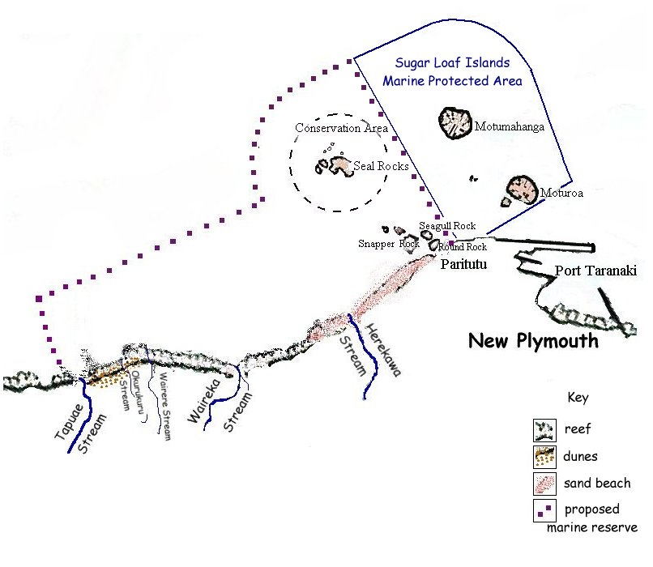
Option 7

‘Suggested Marine Reserve Sites on the North Taranaki Coast’₁₀ gives an overview of the legislative management and biodiversity outcomes of eight management options, and the issues raised about each site during consultation. Option 7 was viewed by the committee as having the most likelihood of support and still meeting the principles of marine reserves (Ballantine _{14,15}).
4. VALUES OF THE PROPOSED MARINE RESERVE

4.1 NATURAL VALUES
The oceanographic conditions and physical features, often volcanic in origin, provide a diverse range of underwater habitats that are unique to Taranaki. Some are distinctive and beautiful; all are typical of the Taranaki Ring plain coast.
Annotated species lists of Plants, Birds and Marine Life of ‘Sugar Loaf Islands Marine Protected Area’ and ‘South West Extension’ are found in the reports referred to in ‘References and Appended Documents’_{2,3}.

4.1.1 HABITAT TYPES
This coastline is generally very exposed, and these widely diverse habitats provide a diversity of marine life _{2,3}.
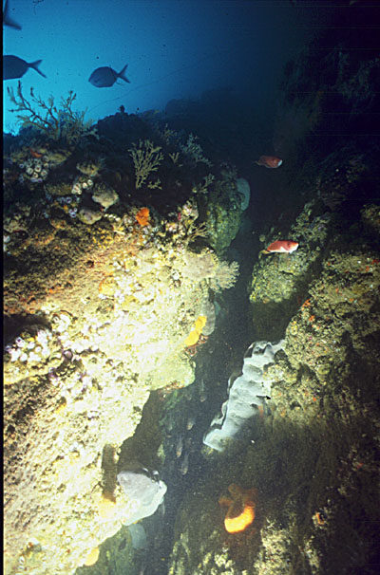
The SLIMPA Conservation Management Plan (Department of Conservation, June 1997) and The Proposed South West Extension Draft Report (June 1991, by the Sugar Loaf Islands Marine Park Interim Management Committee) describe the main habitat types. These are:
SUBTIDAL The ‘Post Office’
  - Caves
  - Rockfaces with crevices and overhangs
  - Steep, narrow crevices
  - Underwater pinnacles
  - Boulder fields
  - Sandy bottom areas
  - Cobble and Boulder reefs (formed from eroded lahar cliffs)

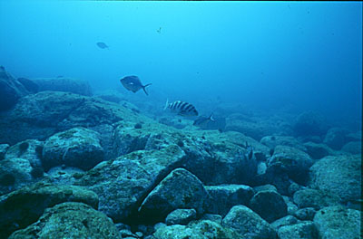

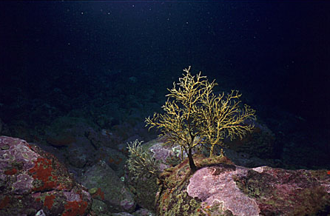

Hydroid tree

Sweep and Red Moki on cobble bottom.
INTERTIDAL
  - Sandy beaches, surrounded by small dune areas (Tapuae Stream Valley), or adjacent to eroding cliffs (Back Beach).
- High water narrow beaches of fine ironsand trapped between laharic reefs and cliffs (South West Extension of SLIMPA).
- Wave-cut platforms (originating from lahars)

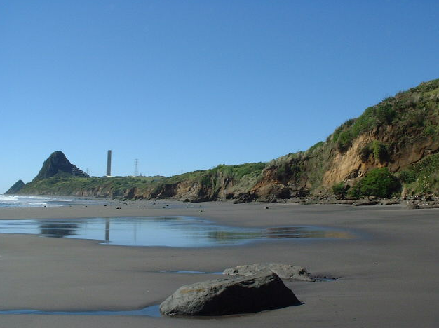

Photo: Elizabeth Mills

LITTORAL
- Cliffs, volcanic in origin, 8-20 metres in height that ‘exhibit well defined dune banding, possibly of national importance’ (DOC 1990).
- Small dune area (North of Tapuae Stream)
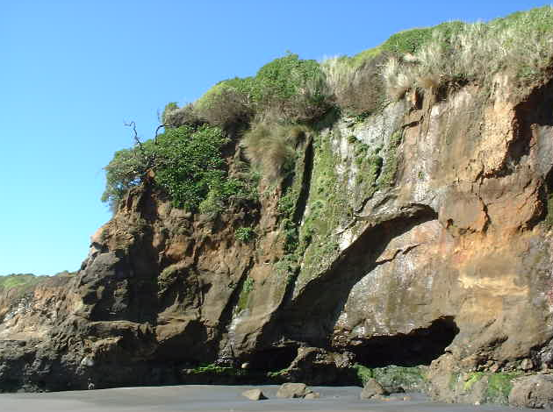

Photo: Elizabeth Mills
4.1.2 MARINE LIFE
Marine life is diverse and abundant. Several species are uncommon. (Hayward and Morley ₂₁)

- Underwater
The area is an important breeding and haul out site for New Zealand Fur Seals, (the northernmost breeding population). The seals are nationally significant. Other marine mammals that have been observed are; common dolphins, pilot whales, orcas, Southern Right whales, and Humpback whales.
Hector’s dolphin, an endangered marine mammal may be seen in these waters.
There are 89 species of fish and 33 species of encrusting sponges recorded within the SLIMPA.
One species of sponge (Latrunculia sp) has bio-active properties and therefore may be important for medicinal purposes.
A variety of hydroids and anemones also occur. 28 species of bryozoans have been identified. Nine species of nudibranch (sea slug), including at least one undescribed species.
Other common fauna include rock lobster, common crabs, echinoderms and molluscs.
Studies of South West Extension subtidal area in 1991 by New Plymouth Underwater Club show a relatively diverse and healthy marine community typical of northern Taranaki.
Patchy areas of boulder and conglomerate rocky reef, interspersed with sand or gravel, support a diversity of organisms. Under 25 metres of water, expanses of sand support beds of horse mussel and are studded with burrows of Mantis Shrimps, tube worms or burrowing bivalves. The rocky reef structures are covered with macroalgae (Ecklonia radiata and Carpophyllum maschalocarpum), sponges, and bryozoans. Kina, sea cucumbers molluscs (chitons, whelks, Cook’s Turban Shells) and starfish forage. The reefs support communities of mussels in varying concentrations. Paua are also collected by customary fishers and the public.
Triplefins and other reef associated fish (Red Moki, Butterfly Perch, Red Banded Perch, Scarlet Wrasse, Spotty, Slender Roughy,) and Short Tailed Stingray are present. Pelagic species such as John Dory, Kingfish, Kahawai, Gurnard, Snapper, Trevally, Mullet and Kelpie are found in the area.

- Birdlife
Approximately 17,000 seabirds nest on the Sugar Loaf Islands annually making it the most important locality for birds on the Taranaki/Manawatu coastline.₂₅ Although this application excludes Moturoa and Motumahanga/Saddleback (the two largest islands and major breeding sites for shearwaters, petrels, terns, shags and the threatened reef heron Egretta sacra), they are interrelated with the surrounding area. The Outer Islands are Wildlife Sanctuaries.
The inner islands are designated Reserves (Motuotamatea/Snapper Rock, Motaora/Round Rock, Pararaki/Seagull) and provide nesting habitat for southern black-backed gull, red-billed gull and white-fronted tern. Grey faced petrels occupy burrows on Pararaki and Motuotamatea (Snapper Rock).
Grey-faced petrels were nesting on small headlands at Waireka in 1991. Mainland nesting sights are extremely rare. However this colony has disappeared. In 1993, a new colony was reported established on Motuomatea, possibly the Waireka colony relocated in response to predators (personal communication, Barry Hartley).
Northern blue penguins and black-backed gulls nest along the South West Extension stretch of coast. The penguins come ashore at night to shelter.
The threatened Australasian bittern, which is considered of national importance, has been located at the Tank Farm Ponds (personal communication, Barry Hartley).

- Other
Taranaki Goldstripe Geckos (Hoplodactylus chrysosireticus) are present on Paritutu Rock. The Conservation Management Plan notes, “A detailed study has not been undertaken to determine if there are lizards on the islands.”

- Vegetation
The low growing, diverse vegetation of the islands and the mainland cliff and dune areas include taupata, karo, flax, rushes, herb and grassfields. They provide vital habitat for a diversity of native fauna. The marine habitat types are closely connected to the coastal (littoral) habitats.
Therefore this application considers the proposed marine reserve in the context of the wider coastal and ocean ecology.
The inner islands of Mataora (Round Rock), Motuotamatea (Snapper Rock) and Parakai (Seagull Rock) have modified plant communities that are similar to vegetation on the adjacent mainland. Taupata forest dominates the steeper slopes of Parakai Island. Karo, flax, coastal herbfields and grassfields are also present. Mataora Island is dominated by flax\rush communities, herbfields and grassfields, with some pohutukawa and flax areas. Motuotamatea Island is dominated by pohutukawa-karo-flax/rushfield-herbfield and grasses with some stands of karo forest.

4.1.3 WATER QUALITY
‘The inshore waters of most of the Taranaki coastline tend to have a relatively high sediment load associated with recurrent wave and storm action, and the provision of sediment from the waterways. The high-energy environment created along the North Taranaki coast creates typically turbid coastal waters, though beyond these waters clearer offshore (oceanic) water exists. The width of the turbid coastal zone varies according to the state of the tide, wind and degree of sediment input from waterways. The clear oceanic water does however move in towards the shore under certain wind and current conditions, usually in summer and early autumn’. (South West Extension Report, p3. ₃)
The lack of siltation from the stony bedded Herekawa and Tapuae Streams provides improved visibility compared to many other areas along the Taranaki coastline. A giant kokopu has been recorded in the Tapuae Stream, which is also an important whitebait spawning area.
4.2 CULTURAL VALUES

4.2.1 MAORI HISTORICAL VALUES
Ngã Mahanga, Ngati Tairi and Ngati Te Whiti share kaitiakitangi of the area and are the recognised tangata whenua. Kaimoana also makes this coast significant for tangata whenua. They call the islands Ngã Motu.
A common boundary is shared between Ngati Te Whiti, (of Te Atiawa), and Ngati Tairi, (of Taranaki) around the base of Paritutu. The islands are of deep cultural significance to the tangata whenua. They contain wahi tapu (sacred places) and have ancestral and historical connections.
- There is an urupa on the submerged reef, Koruanga that is sometimes referred to as Motukuku. (p23 SLIMPA Conservation Management Plan.₂)
- In the Tapuae area is the site of Whiro’s landing place (AD 1270). Petroglyphs (Maori rock carvings) carved in volcanic andesite rocks are found near Waireka and Tapuae.
- The density of pa sites along the coastal area is historically significant.
- There is also a new site under investigation and evidence suggests a moa hunter campsite dating back to 13th and 14th century (p18 South West Extension Report₃).

4.2.2 EUROPEAN HISTORICAL VALUES
The area has been associated with trading and whaling. From 1828, a handful of European traders and whalers, including Dicky Barrett, resided on the mainland at Ngã Motu.
The effects of the Land Wars of the 1860’s were far reaching.
There was a large earthwork redoubt built on the top of Waireka Hill.
Port Taranaki was constructed close to the islands in 1881and had significant impacts on the area.

4.3 AMENITY VALUES

4.3.1 LANDSCAPE / SEASCAPE VALUES
There are uninterrupted views of the coast from the beach and cliffs. The people of the Taranaki region already value this area with its distinctive Sugar Loaf Islands. Three car parks and Centennial Drive provide public access to the views.
The entire foreshore is Harbour Reserve and a significant portion of the land behind the proposed Marine reserve area is in public ownership, and managed by the New Plymouth District Council, including Paritutu Centennial Park. Therefore, it is unlikely that private development will alter these seascape values significantly.

4.3.2 RECREATIONAL VALUES
The area is 5minutes drive from the centre of New Plymouth and is frequently used for a wide variety of purposes.

Non extractive:
Swimming, diving, yachting, surfing, picnicking, kayaking, walking, rock climbing, bird watching, viewing, showing visitors, revitalising, leisure, teaching, boating with small children, seal watching, underwater photography, snorkelling, weddings, passing through by boat, art, camping, scientific study walking dogs, paragliding, remote control aeroplanes, horse riding, motorbikes, jet skiing, power boat racing.

Extractive:
Surfcasting, kaimoana gathering, recreational fishing, diving.

The recreational use survey ₉ indicated a greater use by non-extractive users than extractive users; 77% and 23%.
The southwest end is accessible by foot over private property, and is valued for a wilderness atmosphere since it is cut off by high tides.
There are discussions in progress to enhance New Plymouth’s recreational values. E.g. an artificial surf reef and beach, and an artificial dive reef. This puts pressure on ‘un-improved’ areas close to the city valued for their low impact recreational values. The proposed marine reserve area is one such place.

4.3.3 EDUCATIONAL AND SCIENTIFIC VALUES
Primary and secondary schools and the Taranaki Polytechnic use the area for study. Accessibility is a factor. It is a living classroom and could be a part of the ‘GLOBE’ Project ₁₂ if Ministry of Education were involved.
DOC, Taranaki Regional Council, NIWA, Waikato University and oil companies have conducted scientific studies; some are ongoing monitoring. Protecting the rich marine life and diversity of habitat of an area in close proximity to the Port are some reasons for these projects.
It could also be used in the Ministry of Environment’s Environmental Performance Indicator Programme.
It is scientifically important to have an undisturbed area monitored, which is a baseline for comparisons.

  - COMMERCIAL VALUES
Crayfish are caught commercially in the South West area.
Historically, Wharehou have been caught.
There is one popular tourism operation that includes seal watching and sea kayaking, ‘Chaddy’s Charters’.

4.5 IMPACTS OF HUMAN ACTIVITY
Farming and associated land clearing had a significant impact, and more intense farming continues to have an impact on the marine environment through runoff and sediment brought down the rivers.
In 1874, the population of Taranaki was just more than 8,000.
In 1998, the population of New Plymouth alone was 49,000
An expanding population continues to alter the marine environment through increasing urban runoff and fishing.
The technological developments in the last 150 years has had enormous impact on the marine life – diesel engines and deep freezers allow greater extractive power.
Increasingly accurate modern technology is easily purchased, and used in recreational fishing. This puts increasing pressure on the marine populations. For example, fish finders, depth sounders, GPS, carbon fibre, deep freezes, nylon line, and scuba apparatus are used for extractive recreation. The number of boats is increasing in New Zealand, and many are used solely for recreational fishing.
5. JUSTIFICATION
5.1 MEETS THE PURPOSES OF THE MARINE RESERVES ACT 1971
Section 3(1) of the Act declares that marine reserves have the purpose of preserving "areas of New Zealand that contain underwater scenery, natural features, or marine life, of such distinctive quality, or so typical, or beautiful, or unique, that their continued preservation is in the national interest".
The proposed Ngã Motu Marine Reserve satisfies these criteria. It contains underwater scenery, natural features, and marine life that are both,
1) of distinctive quality, and
2) typical
of the intertidal and subtidal environment of the exposed West Coast/Taranaki Bight area of New Zealand. As such, their continued preservation is in the national interest. See Section 4.1 for discussion of NATURAL VALUES.

5.1.1 Of Distinctive Quality: SLIMPA area.
The SLIMPA area contains the most diverse habitat (rocks, canyons, caves, crevices, overhangs, boulder fields, sand, mud, and lahar reefs), allowing a great variety of marine animal and algal life to live here. The northernmost colony of New Zealand Fur Seal resides here. Two major ocean currents meet, from north and south bringing seasonal changes and greater variety of juvenile fish and larvae. The clear oceanic water moves close to shore under certain wind and current conditions.
Tangata whenua and Taranaki public endorse this high value, which is reflected in local authority policy statements, and Fisheries and Conservation management plans.
- The Taranaki Regional Council has identified it as "an Area of Outstanding Coastal Value” in its Regional Coastal Plan (SLIMPA Management Plan p48 ₂).
- The area of foreshore known as Back Beach is classified as recreation reserve and is managed by the New Plymouth District Council.
- Under the Conservation Act, the Department of Conservation manage the outer islands (Moturoa, Motumahanga, Waikaranga and Whareumu) as Sanctuary Areas, and the inner islands (Motuotamatea, Pararaki and Mataora) as Conservation Areas.
- The Ministry of Fisheries has identified the area around Waikaranga (Seal Rocks) as a 'restricted fishing area' for almost a decade, and recovery of marine life is apparent. It is recognised as the most diverse dive site in Taranaki.
- In 1990, the tangata whenua and communities of Taranaki were deeply concerned about the limited protection of the newly created Marine Park, particularly from oil prospecting and development. After intense public interest, Sugar Loaf Islands Marine Protected Area Act, 1991 (SLIMPA) was introduced as a Private Members Bill and passed in Parliament. This protects the area from oil prospecting, and enshrines it as a public recreational area.
The SLIMPA Management Plan₂ 1997 notes that 'The oceanographic conditions and physical features around the islands provide a diverse range of underwater habitats which are unique to Taranaki.' (p27).

5.1.2. Typical Taranaki Coast: Herekawa Stream to the Tapuae Stream.
The area south west of the SLIMPA is typical of much of Taranaki's coastline, featuring reefs, cliffs. Boulder and sand beaches with limited access at high tide except by boat. (See 4.1)
The proposed Ngã Motu Marine Reserve would therefore fit with the Department of Conservation's policy to establish a network of marine reserves incorporating representative examples of the full range of habitats and ecosystems found in New Zealand's marine environment (Department of Conservation 1995).
The only marine reserve on the west coast of the North Island is at Kapiti Island. The proposal for Paraninihi in North Taranaki has not progressed. See the map of existing Marine Reserves in New Zealand ₁₃.
The establishment of marine reserves is in the national interest as they provide an opportunity, by comparison with unprotected areas, to separate the effects of fishing (see Poor Knights report ₁₈ and ‘Changes in community structure in temperate marine reserves’₁₆) from the ecological effect of other processes. It is therefore important to establish marine reserves that are typical of much larger areas so that the results of this research are widely applicable_{15. 16, 19}.

5.1.3 The Area will be a valuable site for scientific study.
The proposed area fulfills the criteria in Section 3 of the Marine Reserves Act that states that the purpose of marine reserves is to protect areas of sea, seabed and intertidal zones for the “scientific study of marine life”. Section 4.3.3 of this document describes the SCIENTIFIC VALUES.
Because of a port development and oil exploration in an area of high biodiversity and distinctive habitat, the area has been well surveyed and monitored using conventional scientific methods, and sidescan sonar, over the last three decades. Therefore there is an existing body of scientific research to build on (See Section 3.3.1)
The Taranaki Polytechnic have always had a representative on the Nga Motu Marine Reserve Society committee.

5.2 MEETS OTHER LEGISLATIVE REQUIREMENTS
Under Section 4(1) Marine Reserves Act 1971 (MRA), no area for which any lease or licence under the Marine Farming Act 1971 is in force can be declared a marine reserve. Similarly, under Section 4(2) MRA no area within the jurisdiction of any harbour board can be declared a marine reserve without the board's consent. With respect to this application, no marine farming lease or license has been issued for any part of the proposed reserve, and no part of the proposal falls within the jurisdiction of a harbour board, other than navigation purposes.
5.3 THERE IS COMMUNITY SUPPORT FOR THE PROPOSED MARINE RESERVE.
Results from a widely circulated Discussion Pamphlet and accompanying "Have Your Say" survey form indicate wide public support₇.
86% support the principle of marine reserves.
75% support a marine reserve in the proposed area.
86% of people returning forms use the area for a wide variety of uses.
The survey ran from July 1999 to April 2000 and was available at public libraries, through the Fisheries Liaison Committee Minutes, delivery to the closest residents, DOC Information Kiosk at the boat ramp and in the Midweek newspaper clip out advertisement. 142 valid responses were returned by post. Although tangata whenua were welcome to reply, consultation with Ngati Te Whiti and Ngati Tairi took place separately.

  - REGARD FOR TREATY OF WAITANGI
There is provision to continue resolving issues raised by tangata whenua. See Section 3.5 for the concerns of Ngati Te Whiti and Ngati Tairi, and Appendix 1 for consultation details.
Issues raised in discussions with Ngati Te Whiti and Ngati Tairi were:
- concern for the diminishing customary fishing resource especially paua and mussels
- special significance of the area for both hapu
- unresolved boundary with Ngati Te Whiti and Ngati Tairi that is within the proposed area
- preoccupation with resolution of Treaty of Waitangi land issues
- a preference for managed customary fishing to ‘no-take’ areas
- inclusion of a generational review as a safeguard for Maori interests.

There has always been a willingness to discuss issues and no objection to the Ngã Motu Marine Reserve Society continuing to consult with the public despite the lack of resolution with the tangata whenua. We suggest a management committee that is a partnership with tangata whenua.
A generational review would be clearly stated in a marine reserve application, giving an opportunity for tangata whenua to appraise the effects of a marine reserve considering:
- Effects of spillover to customary areas.
- Waitangi Tribunal descisions on boundaries and settlement of grievances.
- Any legislative changes upon expiry of ‘Sealords Deal’ or review of ‘The Marine Reserves Act’.
- Results from the ‘Oceans Policy’.
- Development of Iwi coastal fisheries policy.
A management committee would be a partnership with tangata whenua.

The Nga Motu Marine Reserve Society still see a joint application with tangata whenua as the best option. We continue to consult in good faith within the restrictions of overlapping, ever-changing legislation.

  - A MARINE RESERVE BUILDS ON AND STRENGTHENS THE SLIMPA
The strengths of the SLIMPA Act (1991) are
- Strong public backing for the best protection for an outstanding coastal area used by New Plymouth and wider Taranaki public, many of whom mistakenly believe the area is already a marine reserve. See Fisheries Pamphlet “Recreational Fishing Rules, Central Fisheries Management Area, 1997.”₂₄
- Anecdotal accounts passed down from previous generations of Maori and pakeha users record a remarkable decline in quality and quantity of marine life. See ‘Daily News August 4th 2001, “A World Underwater”₂₃
- It has the good will of many recreational and commercial fishers.
- It has demonstrated the difference between an area of extremely restricted fishing (Waikaranga /Seal Rocks) and the rest of the SLIMPA.
- A culture of compliance already exists.

6. IMPLICATIONS FOR EXISTING AND FUTURE USERS

In general terms all existing and future users will benefit from: -
- improved conditions and habitat for marine life that will produce spillover to surrounding areas₁₉.
- more accurate monitoring of biodiversity, fish stocks, and impacts.

6.1 ADJOINING LANDOWNERS
Any discharges from farming operations are covered by the Resource Management Act
As the landward boundary of the proposed marine reserve may not extend above the level of mean high water spring tides, it will not encroach upon farming operations.
Existence of the marine reserve would not confer right of access onto, or across private land by the Department of Conservation or the public.
At present, access from the Tapuae Stream end is dependent on permission from the landowner.

6.2 COMMERCIAL OPERATIONS
Adverse effects on rock lobster fishing are likely to be temporary as stocks spillover from the ‘no-take’ area. Research ₁₆ conducted at the Cape Rodney to Okakari Point Marine Reserve near Leigh indicates that rock lobster are likely to forage beyond the boundaries.
Similarly, the long-term benefits of spillover may compensate for short-term adverse effect on commercial wharehou fishing. The wharehou spawning area in the S.W. Extension would be protected.
However, there is no legislative framework that allows commercial fishers to recognise the benefits of marine reserves to their fishing.
For the tourist operation, Chaddy’s Charters, fishing will still be an option but in different areas.
For diving and eco tourism, the opportunities are likely to be greater if a marine reserve was established.
Proximity to Port Taranki raises issues of oil spills. This probability should not preclude creating a marine reserve. Operators are already aware of safe practices under the Resource Management Act. Rather it is an opportunity to build more safeguards for the marine life.

6.3 RECREATIONAL FISHING
Initially fishing patterns will be altered as approximately half of the SLIMPA area is included in the ‘no-take’ area. Research shows that spillover will enhance the fishery in the longer term, for example, snapper and spiny lobster₁₆.
Shelter when fishing, an important issue noted in consultation with recreational fishers, will still be available from Moturoa and Motumahanga.

6.4 CUSTOMARY FISHING
Under the Treaty of Waitangi, tangata whenua could claim that customary rights had been extinguished by a no-take marine reserve.
Alternatively, tangata whenua could exercise customary rights by choosing not to take kaimoana and create a koanga (nursery area for future stocks) to enhance customary fishing. Scientific papers_{16, 17} support the concept of marine reserves as koanga.
There would be no customary fishing within the proposed marine reserve area; which will affect Ngati Tairi and Ngati Te Whiti. Concerns expressed by the tangata whenua are:
- pressure on customary fishing from many sources
- access to customary fishing under the Treaty.
Tangata Whenua would be involved in the management and administration of a Marine Reserve. Provision for a generational review of the marine reserve could be an integral part of the application.

6.5 SCIENTIFIC AND EDUCATIONAL USERS
There will be greater opportunities for more accurate study of marine life, biodiversity, and fish stocks provided this is consistent with the purposes and principles of the Marine Reserves Act 1971, and the management objectives of the reserve.
It will provide new opportunities for comparison with unprotected areas, which with benefit all users in the long term.

6.6 IMPLICATIONS FOR MARINE LIFE
The proposed marine reserve will provide an opportunity for marine processes to continue relatively free from human impact. Studies _{16, 18} indicate increased stocks, larval spillover, greater biodiversity would result.
The principle of marine reserves is established by marine scientists and accepted by Ministry of Fisheries, Conservation and Environment as valid ecological insurance against known and unknown future effects on the marine environment_{14, 15, 17}.
Natural movement of sand in large quantities along the coast impacts on, and kills off many marine organisms. It is a natural process with known effects. Population elasticity allows for recovery particularly in undisturbed areas. Bruce Hayward noted “Once the sand recedes the previous diversity of intertidal life could be expected to recolonise and return within a few years, reseeded from unimpacted refuges locally, and more distant”. ₂₁
7 PROPOSED MANAGEMENT

7.1 LEVEL OF PROTECTION
Absolute protection for all life within in the boundaries of the Ngã Motu Marine Reserve.

7.2 PUBLIC ACCESS, NAVIGATION AND ANCHORING
Public would have access to the Ngã Motu Marine Reserve, using the same access routes as are currently available to the area.
The reserve would be outside the navigation lanes which are in the approaches to Port Taranaki.
The Department of Conservation could provide mooring buoys for dive boats, where appropriate.

7.3 BOUNDARY IDENTIFICATION
The Department of Conservation will deploy buoys and land markers to allow the boundaries of Ngã Motu Marine Reserve to be identified.

7.4 COMPLIANCE AND LAW ENFORCEMENT
The experience gained in the administration of SLIMPA should facilitate a smoother transition to a reserve in this case, than would be the case with proposals elsewhere in the country. The public already has a mistaken perception that the area of SLIMPA is fully protected. Therefore, the administration and compliance costs are unlikely to place undue burdens on DOC. Since the Ngã Motu Marine Reserve will have minimal impact on commercial fishing, this sector is likely to comply.

7.5 MONITORING AND SCIENTIFIC RESEARCH
Ongoing monitoring will allow an analysis of the effects of the Ngã Motu Marine Reserve, as baseline studies have already been done by the Department of Conservation and Dr Bruce Hayward.₂₁

7.6 EDUCATION AND INTERPRETATION
There is an Interpretation Centre for SLIMPA, and publications about the area are widely available. These resources may be updated with relative ease to accommodate the information required for Ngã Motu Marine Reserve.
7.7 COMMITTEE
The day to day management would be the responsibility of the Department of Conservation. One possibility would be to establish a committee to represent various interest groups, weighted in favour of tangata whenua, to advise and assist with the management of the reserve. This has been established at the Te Tapuwae o Rongokako Marine Reserve at Gisborne. The Taranaki / Whanganui Conservation Board could agree to adopt this committee and delegate appropriate statutory powers to it.

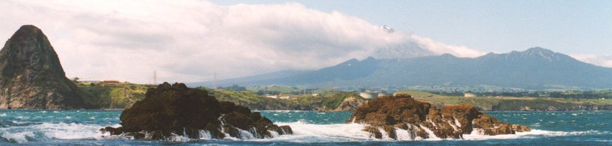

Photo: Val Deakin
View of the proposed Ngã Motu Marine Reserve from the sea, looking south.

References and Appended documents.

- Marine Reserves Act 1971, Section 5, Marine Reserve Establishment Process.
- “SLIMPA Conservation Management Plan”, DOC, 1997
- “Proposed South West Extension, Draft Report”, A Report of the Sugar Loaf Islands Marine Park Interim Management Committee, June 1991.
- SLIMPA Private Members Bill.
- The New Zealand Biodiversity Strategy, 2000, DOC and Ministry of the Environment.
- “Setting Course for a Sustainable Future, The Management of New Zealand’s Marine Environment” (December 1999) from the Office of the Parliamentary Commissioner for the Environment.
- Public Discussion Pamphlet (attached), 1999, The Ngã Motu Marine Reserve Society Incorporated.
- Schedule of Consultation (attached) The Ngã Motu Marine Reserve Society Incorporated.
- “Recreational Use Survey” December 1999 – February 2000, The Ngã Motu Marine Reserve Society Incorporated.
- “Suggested Marine Reserve Sites on the North Taranaki Coast”, 2000, The Ngã Motu Marine Reserve Society Incorporated.
- Baseline surveys in the Nga Motu area. The Ngã Motu Marine Reserve Society Incorporated.
- ‘GLOBE’, Learning Experiences Outside the Classroom, Curriculum Division, Ministry of Education
- Map of existing Marine Reserves in New Zealand
- Ballantine, W. J., (1997) “Design Principles for Systems of “No-Take” Marine Reserves”, ‘Design and Monitoring of Marine Reserves’ Workshop, University of British Columbia, Vancouver, February 1997.
- Ballantine, W. J., (1999) “Marine Reserves in New Zealand”, MPAs Workshop, KORDI, Korea, November 1999.
- Babcock, R. C. et al, (1999). “Changes in Community Structure in Temperate Marine Reserves”, Marine Ecology Progress Series, 189, 125-134.
- Roberts, C.M. and J.P. Hawkins, (2000). Fully-protected marine reserves: a guide. WWF Endangered Seas Campaign, 1250 24th Street, NW, Washington, DC 20037, USA and Environment Department, University of York, York, YO10 5DD, UK.
- Roberts, C. (1997) “Ecological Advice for the Global Fisheries Crisis” TREE 12, 35-38.
- Willis, T. and Denney C., (2000). “Effects of the Poor Knights Marine Reserve on Demersel Fish. Report to the Department of Conservation, Science and Research Grant N0. 2519.
- Wolfenden, J., Cram, F., and Kirkwood, B., (1994). “Marine Reserves in New Zealand: A survey of Community Reactions”, Ocean and Coastal Management 25, 31-51.
- Hayward, B., and Morley, M. (July 2001). “Intertidal Biota of the Proposed Nga Motu marine Reserve, New Plymouth”.
- National Overview of Biological Monitoring in New Zealand’s Marine Protected Areas., Department of Conservation, 2001.
- “Daily News”, August 4th 2001, “A World Underwater”.
- Fisheries Regulations Pamphlet “Recreational Fishing Rules, Central Fisheries Management Area, 1997.”
- Hartley, B., ‘Sugar Loaf Islands, species of birds recorded’, updated 18 May 2001.

