Optimising marine reserve design in New Zealand – Part II: Individual-Based Models.

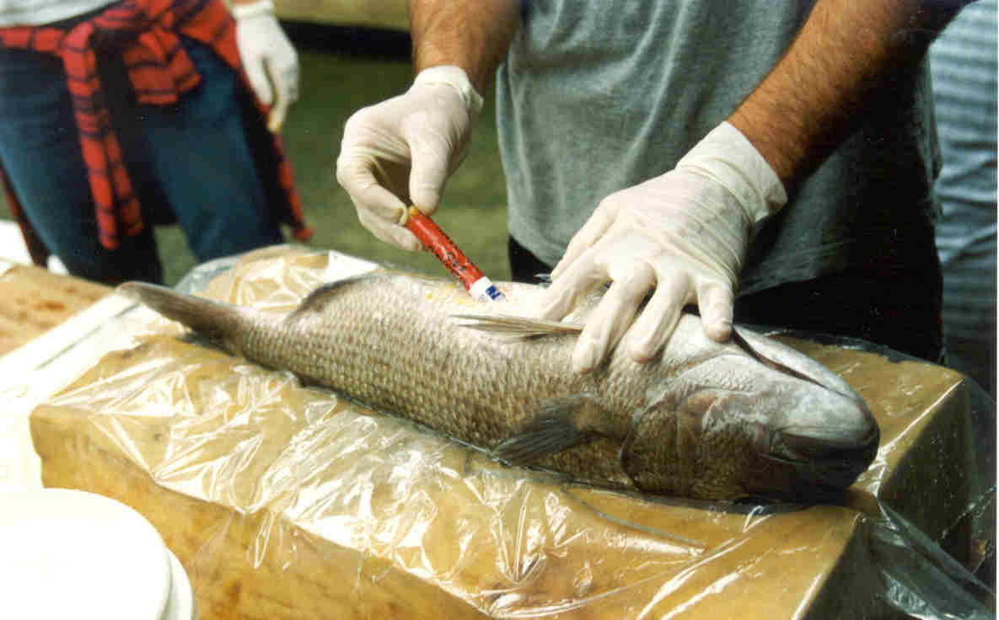

Report to the Department of Conservation, Auckland Conservancy

R.C. Babcock, C.G. Attwood, D.P. Egli, D.Parsons & T.J. Willis

Leigh Marine Laboratory
University of Auckland
P.O. Box 349
Warkworth

December 2002

Executive summary

- Detailed behavioural data from a variety of sources was used to construct individual-based models of snapper populations in marine reserves. Predictions of the model were not significantly different from measured snapper abundance ratios in scenarios run for two marine reserves, at Leigh and Tawharanui. The models are therefore considered a valid tool for examining a range of scenarios relating to size, shape and effectiveness of marine reserves with respect to snapper.

- When expressed as a fraction of the snapper population in a “virgin” state (the complete absence of fishing anywhere), snapper populations within existing marine reserves at Leigh and Tawharanui have achieved abundances less than 30% of their potential. Even doubling the size of these reserves would produce an inconsequential increase in the level of protection.

- Reserves in the order of 40 km² or more are required in order to achieve abundances greater than 50% of the unexploited stock. Increases in reserve size beyond this point are predicted to result in a diminishing rate of return in terms of level of protection.

- Egg production per recruit is strongly influenced by reserve size, and snapper populations within existing marine reserves at Leigh and Tawharanui are predicted to achieve egg production less than 20% of their potential. Egg production per recruit is not predicted to approach 50% of virgin egg production until reserve sizes are greater than 100 km² .

- Comparative age-structures of fish populations in fully exploited areas, marine reserves and virgin populations all differ substantially, however the population structure within reserves resembles that for a fully exploited population more closely than a virgin population. Due to the level of movement shown by snapper, fish are not “locked up” by reserves and fish with home ranges based in reserves are predicted to have a relatively high chance of being caught outside the reserve. On balance, marine reserves with a size similar to Leigh and Tawharanui err in favour of fishing rather than conserving snapper populations.

- Predictions of the model are sensitive to variations in the level of fishing mortality on coastal reefs, the proportion of fish displaying highly resident vs wide ranging vs migratory behaviour, and whether fish return to the same area of coast year after year. Continuing strategic research on key elements of snapper behaviour can enhance the accuracy and credibility of the model further, through continued and expanded acoustic tagging studies.

Table of contents
Optimising marine reserve design in New Zealand – Part II: Individual-Based Models. 1
1. Executive summary 2
Table of contents 4
2. Introduction 5
2.1 Modelling the response of fish species to Marine Reserves 5
3. Methods 10
3.1 Description of individual-based model 10
3.2 Using telemetry data in the model 11
3.3 Summarising the results 13
3.4 Parameter values 16
3.5 Reserve design alternatives 17
4. Results 18
4.1 Home-range size 18
4.2 Leigh and Tawharanui: existing reserves 21
4.3 Leigh and Tawharanui: Alternative designs 22
4.4 Sensitivity to key parameters 24
5. Discussion 25
5.1 Model validation 25
5.2 Marine Reserve Size 26
5.3 Interpretation. 27
6. Acknowledgements 28
7. References 29

2. Introduction

2.1 Modelling the response of fish species to Marine Reserves
In the absence of long-established well-enforced marine reserves of adequate size to allow the direct measurement of marine reserve effects, many of those interested in the effectiveness (e.g. Polacheck 1990, DeMartini 1993, Attwood & Bennett 1995, Sladek-Nowlis & Roberts 1999) or otherwise (Parrish 1999) of marine reserves have utilized numerical models of fish populations to explore their effectiveness. This approach has the merit of enabling a range of scenarios to be examined over a very short period of time, at least relative to the periods that would be required to obtain the same information by empirical means. Unfortunately many such models are constructed based on limited or non-existent data, and apply to hypothetical fish populations.

Significant levels of uncertainty surrounding such models are often ignored or played down, at least until they appear to produce contradictory results. An example of this can be seen by comparing the results of the model of Parrish (1999) for California groundfish, with those of Hastings & Botsford (1999). Parrish concluded that the impacts of reserves would be detrimental to the fishery because of displacement of fishing effort, while Hastings and Botsford’s model showed that even with high proportions of reserves the yield of the fishery would be similar to what it would be without protection. Other concerns surrounding the use of models not based on realistic behavioural data springs from suggestions that the greatest fisheries benefits from marine reserves may come from closures of 40% - 50% (Lauck et al 1998, Sladek Nowlis and Roberts 1999). Such closures would constitute very significant areas of the sea, consequently any variation in the estimates will also affect large areas.

Clearly, unless models incorporate a realistic understanding of fish behaviour and biology their usefulness will be limited to a very general level. However in many cases, certain species are of particular importance either ecologically or to the fishery, and these species may possess characteristics that do not conform well to “average” parameters. Alternatively the geographic location may introduce particular constraints that limit the usefulness of a general model. In such cases general models will be of limited usefulness. Attempts to use numerical modelling to understand the dynamics of fish populations in marine reserves at fine scales, including the interaction of fish mobility with habitat and reserve size have been made (Chapman & Kramer 1999, Kramer and Chapman 1999), and have produced some thought provoking results. However these models have relied on simplistic assumptions, including uniformity of fish behaviour within the population and between seasons.

Mobility of a species or individuals throughout their life history will influence the degree of protection that a marine reserve of any particular design can provide. Models examining the relationship between the dispersal range, site fidelity and degree of protection, propose that reserves will provide maximal protection for species with high site fidelity and low dispersal range (Kramer & Chapman 1999). While high site fidelity and low adult dispersal range will mean that fish resident within reserves receive maximum protection, they are also, by definition, less likely to “spillover” into fisheries outside reserves. This has important implications for the use of marine reserves as a tool for enhancing fisheries yield, since if fish don’t spillover there will be no enhancement of yield unless by egg export. “Spillover” is most likely to contribute to fisheries adjacent to the reserve if a species has an intermediate degree of movement, spending enough time inside protected areas that individuals will increase in size before capture, but not so much that they have no likelihood of being captured. At the other end of the spectrum are species that are so mobile that they never spend enough time inside reserves to benefit from protection, with no benefits for protection or spillover.

It is crucial for any effective marine reserve design to gain detailed knowledge on the mobility and habitat utilisation of its inhabitants (Roberts and Polunin 1991, Attwood and Bennett 1994, Zeller 1997) as improperly designed reserves may provide a false sense of security for fisheries and conservation. In order to be effective, a marine reserve must be big enough to retain a sufficient proportion of the protected population long enough for positive effects such as increased diversity, size, density, fecundity, or changes in the habitat to be realised (Polacheck 1990). Acquiring individual based movement data in combination with density distribution and changes, and habitat information allows a new degree of insight into the part of teleost life history.

Snapper (Pagrus auratus) are one of the most ecologically and commercially important marine fish species in New Zealand, and many other parts of the world, and also one for which assumptions of uniform behaviour are clearly invalid. While snapper follow a seasonal migration in to shallow water (Crossland 1976, Cassie 1956), this migration is followed only by some fish in the population (e.g. Willis et al. 2000). The seasonal build-up of snapper in coastal marine reserves in summer, and the reduction of snapper density over winter, is more consistent with an alternative theory of polymorphic snapper behaviour, that is a proportion of P.auratus are year round residents on reefs (the 'Kelpie' theory).

Snapper resident on reefs can display high site fidelity and tagged fish have routinely been sighted in the Cape Rodney to Okakari Point Marine Reserve after periods longer than 3 years (Willis et al. 2001). A re-sighting has recently been made 6 years after tagging (Babcock, unpublished observations). Acoustically tagged snapper have been shown to have high levels of site fidelity, with the widest ranging fish having a core area of 300 m2 but representing a spectrum of site-attached behaviour (Parsons et al. 2000). For example some fish appeared to make excursions from their home range in summer that may have been spawning-related. More recently further acoustic tagging work in the CROP marine reserve has shown that, in addition to this highly site-attached behaviour, some snapper move more widely while resident on reefs, making excursions on the scale of several kilometers. Some of these fish have been shown to leave the reserve and return to it after extended periods (Egli & Babcock 2002).

The growing detail of our knowledge of snapper behaviour provides the opportunity to construct a realistic numerical model of snapper populations and how they respond to protection from fishing. Because the assumptions on which the model is based are founded on actual observations of the species there is a reasonable probability that the behaviour of populations simulated in the model will bear a robust resemblance to natural populations. Furthermore, because we have an extensive data set that has actually measured the population structure and relative density of populations inside and outside of several reserves, we have a means of validating the model. This is a crucial aspect of modelling that is usually lacking from assessments of marine reserves. However, should the models resemble the natural populations with some degree of accuracy, we are in a position to examine the implications of a range of scenarios without having to wait for empirical results. This has obvious advantages for conservation and even fisheries management, and we can be reasonably confident that the conclusions will be correct, at least in broad detail.

In this paper we describe a geographically-correct, individual-based model that computes post-recruit survivorship and life-time fecundity of snapper that recruit into a marine reserve. The model is restricted in geographical scope to the immediate vicinity of the reserve and does not include recruitment processes, nor the broader stock dynamics. The model specifically considers the extent to which snapper that recruit in a marine reserve are protected from the adjacent fishery. The basis for these calculations is provided by the movement data (Parsons et al. 2000, Egli & Babcock 2002), from which home-range movements are estimated.

An important question underlying the modelling exercise is how large a reserve should be to protect snapper. It stands to reason that a reserve should be larger than the range over which a fish moves, but there will inevitably be a substantial number of fish that reside near the boundaries that will experience partial exposure to the fishery. Overall, therefore, no reserve can be expected to protect its inhabitants fully. Whereas the estimation of the size effects should involve a simple comparison of reserve area and home-range size, an analytical model could not be used for snapper. Movement studies showed differences between individuals with respect to movement behaviour that made an analytical approach intractable. In addition, fishing mortality rates varied substantially between inshore reefs, where snapper spend the summer, and deep water to where some snapper migrate in winter. The individual-based model performs these calculations by laboriously simulating the life of thousands of fish that vary with respect to their position and behaviour, and then aggregates the results.

Apart from the existing reserves at Leigh and Tawharanui, the model is applied to alternative designs at both locations to explore the effect of reserve size. Further consideration of reserve shape necessitated a model of hypothetical rectangular reserves, for which length and width dimensions could be conveniently manipulated.

3. Methods

3.1 Description of individual-based model
A rectangular area larger than the reserve being modelled was divided into 100 m x 100 m cells (0.01 km²). Each cell was indexed twice according to a chart, firstly to denote whether it represented land or sea, and secondly to indicate if the cell was part of the reserve (i.e. where no fishing occurred) or not. The grid of cells was used to represent the use of space by individual snapper, and their susceptibility to the fishery on a probabilistic basis.

Snapper recruits were assigned randomly to cells that represented sea. The total number of recruits was sufficiently large to ensure that each cell received approximately 50 recruits, thus effectively eliminating random biases in the distribution of fish across the grid. No attempt was made to mirror habitat preference when distributing fish, primarily because habitat use has not been studied sufficiently to allow for its quantification. The longevity of each snapper was modelled stochastically on the basis of its use of cells and the probability of it dying in each cell. A random number generator (RAN0) was used to decide if the fish survived the month according to the calculated mortality risk. If the fish survived the month, then its trial continued into the following month, and so forth. The number of fish surviving each year (or age-group) was counted to yield an age-distribution.

The mortality risk for any one month was calculated by summing, across all cells, the product of the probability of the fish occupying that cell and the probability of it dying in that cell. For those cells inside the reserve, the rate of mortality (Z) was set to equal the natural mortality rate (M). For those cells outside the reserve, the rate of mortality was set to equal the sum of the estimated natural mortality rate and fishing mortality rate (F). The distribution of the probability of cell occupation was derived from telemetry data.

3.2 Using telemetry data in the model

The probability of a fish occupying any particular cell within a month was estimated from telemetry data derived from two sources. Parsons et al. (2000) tracked five fish with the VEMCO RAPT system of three acoustic receivers, which estimated the position of fish by triangulation. Egli & Babcock (2002) used an array of seven receivers with a combined signal-receiving range of 5.4 km², from which the positions of eight fish were inferred by the relative strengths of the recorded signals at each receiver position. In both cases, the data were summarised by month into a two-dimensional grid of probabilities, by calculating the proportion of time each fish spent in each 100 m x 100 m cell.

The home-ranges for individual fish were never symmetrical in shape. The cell most frequently used (called the home cell) was often offset to one edge of the range. It would be incorrect, for the purpose of this model, to calculate the home-range size and then to model it as a circular shape. Such a procedure would under-estimate the absolute distance that a fish might travel in its home-range, due to the fact that most fish had oblong-shaped home-ranges. Because there did not appear to be any trend for fish to forage predominantly on the seaward, or shoreward side of the home cell, it was assumed that the home-range of a fish could elongate in any direction from the home cell. The two-dimensional grid of probabilities was then summarised into one-dimension by grouping together all those cells that were an equal distance away from the home cell. Such groups included either four or eight cells (Fig. 1). The distance (d) between any cell (at address x,y) and the home cell (centre of the home-range at address x_{c},y_{c}) was calculated using pythogoras’ theorem,

$d=\sqrt{(x−x_{c})^{2}+(y−y_{c})^{2}}$ Equation 1.

The probability of a fish occupying cells equidistant from the home cell were summed, and recorded against the radius calculated by equation 1, thus yielding a list of multinomial probabilities for cells located at radii (in m) of 0, 100, 141, 200, 232 etc. These probabilities describe the likelihood of a fish occupying a position at a given distance from the home cell, but directional information is lost. The multinomial probabilities that were used in the model were average values calculated from the tracked fish.

Figure 1. To obtain a radially-symmetrical probability density, the occupational probabilities in cells that were an equal distance from the home cell (HC) were added together. Here the first four radii are shown. Circles 1, 2 and 3 each fall on the centre of four cells, but circle 4 falls on the centre of eight cells.

For groups of cells spaced equally from the home cell, the probability of occupation decreased. Accordingly, with increasing distance from the home cell, the cumulative probability of occupation increased at an ever-decreasing rate, to the point at which all recorded positions were encompassed. This cumulative distribution was used to define the radii that encompassed 90 and 99% of the fishes’ movements within the period under investigation.

Each fish was assumed to have a circular probability density distribution centred on the cell to which it recruited for the purpose of evaluating its risk of exposure to the fishery. Note that the probability density distribution was larger than the original home-ranges from which it was calculated, by virtue of it being circular, but the proportion of time spent at any given distance from the home cell was the same. It was important to conserve the distance component, rather than the actual size, when evaluating the risk of exposure to the fishery beyond reserve borders.

During the execution of the individual-based model, the above procedure was reversed. The proportion of time spent in the cell to which a model fish recruited (home cell) was higher than in any other cell. The probability of that fish occupying other cells was calculated from the multinomial probability distribution described above. Such probabilities had to be divided by either four or eight, depending on the number of cells in the radius-group to calculate the probabilities for each individual cell. In cases where the probability density distribution overlapped land, the multinomial probability was divided among only sea cells. In this way, the model fish filled the available space without any distortion of the distances that it moved within the home-range.

It was observed that some fish left the study area towards the onset of autumn. Such behaviour was predicted, because the number of snapper on inshore reefs varied seasonally due to partial offshore migration (Willis et al. in press, Egli & Babcock 2002). Therefore, the model made allowance for a certain proportion of fish, deemed to be migrants, to leave the inshore reefs for the months April to September. During this period, the migrants were at risk of being captured by the offshore fishery. In the absence of information to the contrary, it was assumed that migrants return to the same home cell each spring.

3.3 Summarising the results
The model rests on the assumption that recruitment is constant over space and time. While we know that this is not the case in nature (e.g Kingett & Choat 1981, Francis 1993) it is a simplifying assumption that is unlikely to be affected by marine reserve status. Because of the limited geographical scope, the spawner-biomass that determined recruitment was a function of much larger processes that were beyond the scope of this investigation. The model therefore presents results on a per-recruit basis, in much the same way as yield per-recruit and spawner-biomass per-recruit models are used to analyse fishing strategies.

Because recruitment in the model did not vary over time, and because fishing and natural mortality were also constant over time, the density of fish could be calculated from the projection of a single cohort . If the number of fish recruiting to cell (i,j) is R_{(i,j)}, and the number of those surviving to the end of each year (t) is S^{t}_{(i,j)}, then the density per-recruit (D/R) for cell (i,j) is:

$D/{R_{(i,j)}}=\frac{\sum_{t=t_{r}}^{t_{\text{max}}}{S_{(i,j)}^{t}}}{R_{(i,j)}}$ , Equation 2

where t_{c} is the age at recruitment, and t_{max} is the maximum age attainable by snapper. A variant of this indicator summed over the interval t_{c}:t_{max} to include only mature fish.

The density of fish in the reserve was simply the average of all D/R_{(i,j)} values over those cells included in the reserve. Likewise, the density of fish in the exploited area was the average of all D/R_{(i,j)} values over the exploited cells. One measure of the effectiveness of a marine reserve is a simple comparison of fish density across a marine reserve boundary. The average D/R in the reserve was thus compared against the average D/R for the exploited area. Assuming uniform recruitment, that ratio can be compared to field measurements.

The ratio of density between the reserve and the adjacent exploited area does not provide an absolute measure of protection effectiveness since both reserve and non-reserve fish are affected by fishing. For this reason, a comparison of density per-recruit against the density per-recruit in the hypothetical situation of no fishing anywhere was necessary. D/R_{k} is the notation used to describe the D/R that would result in the complete absence of fishing. D/R_{k} was calculated by summing the cohort strengths when only natural mortality applied, and then dividing that sum by the original recruitment strength. The mean D/R for all reserve cells was then expressed as a percentage of D/R_{k}, yielding a value that could range from 0 (no protection) to 100% (maximum possible protection).

D/R values reflect only numbers of fish and carry no information about the structure of the stock locally. Egg production (EP) is a useful measure of protection, because it includes age-structure, and provides a direct measure of the capacity of the fish to contribute to future recruitment. Again, this parameter is expressed as a per-recruit figure:

${\text{EP}}/{R_{(i,j)}}=\frac{\sum_{t=t_{m}}^{t_{\text{max}}}{(S_{(i,j)}}E(t))}{R_{(i,j)}}$ , Equation 3.

where t_{m} is the age at 50% onset of maturity, and E(t) is the mass of eggs produced by a fish of age t. This latter function was constructed from an age-mass relationship and an egg-mass relationship, the parameters of which are described below.

The number of fish surviving at the end of each year since recruitment was used to construct an age-distribution for fish in the reserve, and another for fish in exploited areas. The numbers-at-age were log-transformed and then regressed against age to yield a slope (Pauly 1984). The value of the slope was taken as a measure of instantaneous mortality rate, with units y⁻¹.

In summary, the protective value of the reserve was measured by four variables:
- Ratio of density per-recruit inside the reserve to outside, (a) for all fish and (b) for mature fish only);
- Percentage of the maximum density per-recruit inside the reserve (mature fish only);
- Percentage of the maximum egg-production per-recruit inside the reserve;
- The mortality rate of fish in the reserve (calculated over the exploited ages only).

3.4 Parameter values
Estimates of critical ages and rates were derived from published sources (Table 1). A two-tier natural mortality rate was used, with fish over 20 years being at lower risk. With respect to fishing mortality, inshore reefs and offshore areas varied by an order of magnitude. The growth function, taken from Millar et al. (1999), is a power curve:

$\text{Length}=\text{15}\text{.}1(t−0\text{.}\text{856})^{0\text{.}\text{395}}$ equation 4.

Fish mass was related to length as follows (Taylor and Willis 1998):

$\text{Mass}(g)=0\text{.}\text{00007194} \text{Length}(\text{mm})^{2\text{.}\text{793}}$ equation 5.

Fecundity (number of eggs produced) was related to mass as follows (Zeldis and Francis 1998):

$\text{fecundity}=\text{73}\text{.}9∗\text{mass}(g)−\text{7793}$ equation 6.

Table 1. Parameter values used in the model. M = natural mortality rate, F = fishing mortality rate and , t = age at recruitment (r), first capture(c), 50% maturity (m) and maximum age (max).

Parameter | Chosen value | Units | Reference
M (< 20 years)  M (≥ 20 years)  F (inshore reefs)  F (offshore)  t_{r}  t_{c}  t_{m}  t_{max} | 0.075  0.05  1.0  0.1  1  5  5  50 | y⁻¹  y⁻¹  y⁻¹  y⁻¹  y  y  y  y | Davies, Gilbert & McKenzie 1999  Davies, Gilbert & McKenzie 1999  Millar and Willis 2001  Davies, Gilbert & McKenzie 1999  Francis 1994  Davies, Gilbert & McKenzie 1999  Francis & Pankhurst 1988  Gilbert & Sullivan 1994

3.5 Reserve design alternatives
The existing reserves at Leigh and Tawharanui were used as test cases, but then each of these was also modified to provide smaller and larger alternatives (Fig. 2, Table 2). These alternatives provided a rather limited range of reserve sizes, and so a hypothetical rectangular design was created, to provide for a range of larger reserve sizes (Table 2). These reserve had three open boundaries (two short and one long) and one closed (representing the shore). There was little merit in testing smaller reserves than the two smaller versions of Leigh and Tawharanui.

Table 2. Reserve dimensions. In the case of Leigh and Tawharanui, the length and width refer to the maximum east-west dimension and the maximum north-south cross-section respectively. Hypothetical rectangular reserves are prefixed with the letter H.

Reserve design | Length (km) | Width (km) | Area (km²)
Small Leigh  Existing Leigh  Large Leigh  Small Tawharanui  Existing Tawharanui  Large Tawharanui | 2.0  3.7  4.4  1.6  3.6  4.6 | 1.2  1.2  1.2  1.1  1.1  1.1 | 1.9  3.3  4.6  1.5  3.1  4.0
H1  H2  H3  H4  H5  H6  H7 | 5  10  10  20  20  40  60 | 2.0  2.0  4.0  4.0  6.0  6.0  6.0 | 10  20  40  80  120  240  360

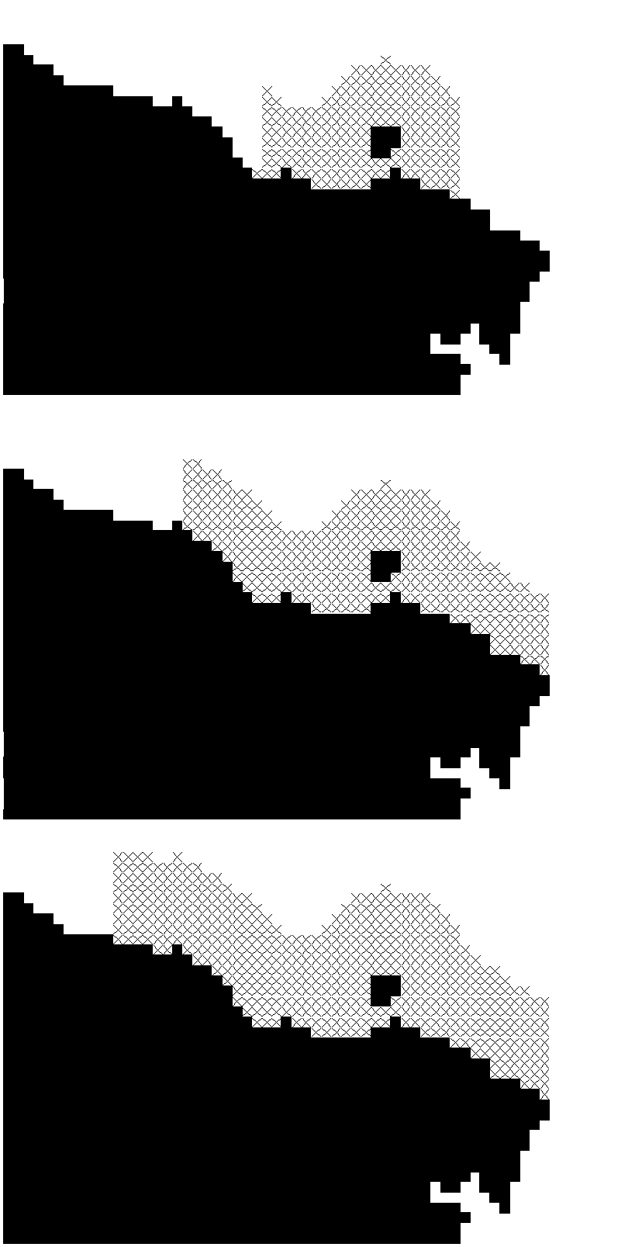
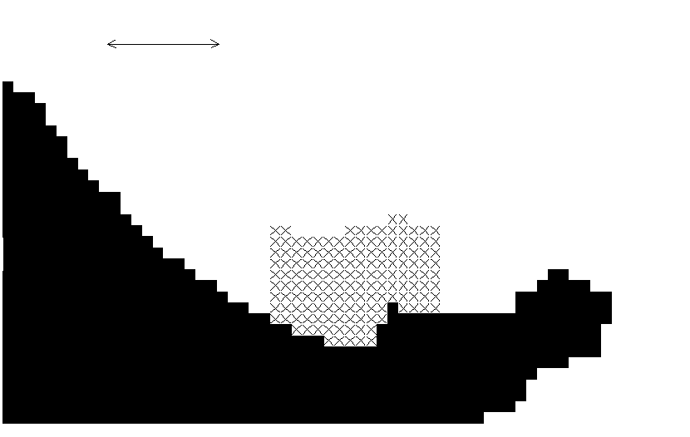
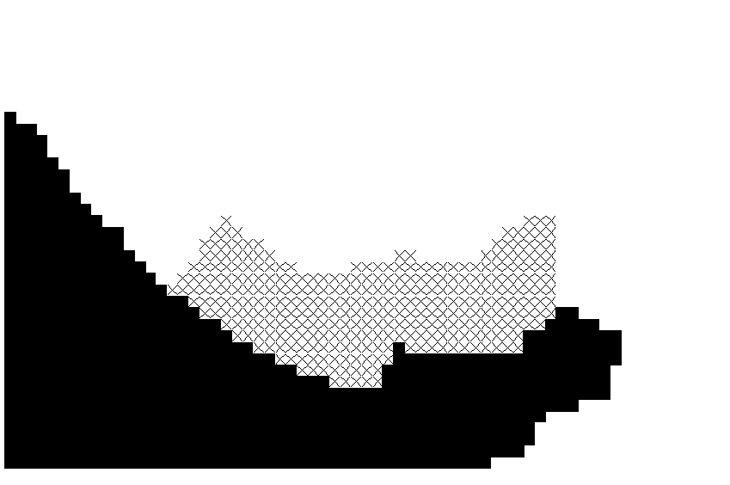
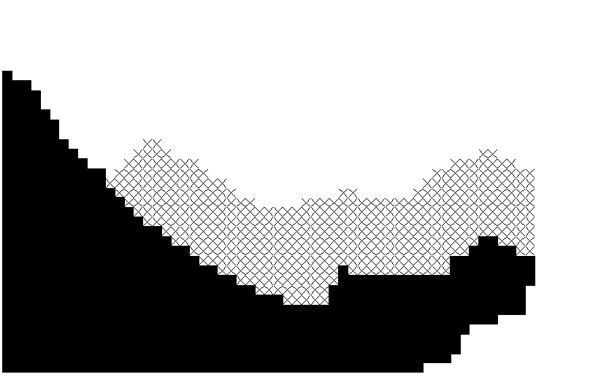

Figure 2. Maps of Leigh (left centre) and Tawharanui (Right centre) reserves, with alternative designs above and below that were used in the simulations. Scale bar 1 km.

4. Results

4.1 Home-range size
The initial tracking experiments conducted with the RAPT system of buoys showed that snapper were highly resident. More than 80% of the fish’s time was spent within a radius of 200 m (Fig. 3, also see Parsons et al. 2000). These estimates, while variable over time and between fish, showed no trend over the six months of the experiment (Table 3).

A second experiment using an array of seven hydrophones found that some fish were highly resident as described before, but that others had a notably expanded range during some, but not all, months of tracking (Table 3). In these expanded ranges, 80% of the fish’s time was spent within a radius of approximately 1300 m (Fig. 3). From the short time-series available it appeared as if the expansion of the range occurred for one or a few months during the summer period, but the data were not conclusive. Not all fish expanded their range at the same time or for the same duration. Indeed, some did not expand their range at all. The absence of a similar phenomenon among the RAPT tracked fish suggests that any tendency to expand the range is not universal.

Figure 3. Cumulative probabilities plotted against radius for two home-range sizes.

Another phenomenon among some of the fish that did show an expanded range, was an abrupt disappearance from the reception area. It can be assumed that these fish migrated offshore.

For the purpose of modelling fish movements with respect to reserve boundaries, two distinct home-range sizes were recognised. At this stage it is difficult to assign any biological meaning to the distinction, although it is tempting to speculate that the larger home-range is a result of mid-summer spawning or courtship. The two home-range sizes were estimated from the data as indicated in Table 3.
Because neither of the two studies tracked fish for a full year, and because sample sizes were small, it is difficult to gauge the mix of behavioural types with any degree of certainty. The proportions used in this study were that 60% were migratory with an expanded summer home-range. This was based on the change in numerical abundance of snapper at the Leigh Marine Reserve between October and February (Egli and Babcock 2002, Fig. 21). Of the remaining fish, half (20%) were assumed to be resident with small home-range ( all 5 fish tagged by Parsons et al. 2000), and the other half (20%) resident with expanded home-range (the 5 non-migratory fish tagged by Egli & Babcock (2002). Alternative proportions were investigated in a sensitivity analysis.

Table 3. The radius that encompasses ninety and ninety-nine percent of fish movement calculated on a monthly basis. Fish with the 6000 labels were tracked by the RAPT buoys. Fish labelled 1-9 were tracked by an array of seven moored hydrophones. Values in normal font were used to estimated the small home-range, whereas those in bold were used to estimate an expanded home-range.

Fish | Size | Oct | Nov | Dec | Jan | Feb | Mar | Apr | May | Jun
6785  6786  6787  6788  6789  1  4  6  7  8  9 | 90 % limit of activity radius (m)
6785  6786  6787  6788  6789  1  4  6  7  8  9 |  | 316  223 | 1640  510 | 1740  1616  510  1581 | 223  1513  1081  1404 | 224  100  200  141  141  316  640  1404  510 | 300  100  141  223  223  761  447  500 | 316  200  141  282  223 | 224  200  200  223 | 316  141  224  316
6785  6786  6787  6788  6789  1  4  6  7  8  9 | 99 % limit of activity radius (m)
6785  6786  6787  6788  6789  1  4  6  7  8  9 |  | 632  360 | 1835  1204 | 1835  1835  1300  1811 | 500  316  223  670  1431  1803 | 608  316  283  282  282  670  1431  1612  824 | 707  316  283  282  223  854  781  500 | 707  316  300  447  282 | 539  316  400  300 | 600  400  400  447

4.2 Leigh and Tawharanui: existing reserves
On a per-recruit basis, the density of snapper is predicted to be 1.5 times greater in the reserve than in adjacent exploited areas (Table 4). When including only mature fish in the comparisons, the ratio climbs substantially to 10.6 (Leigh) and 11.7 (Tawharanui). In both cases, however, the density per-recruit of mature fish is only one-quarter of the maximum possible density per-recruit, i.e. the density per-recruit of mature fish in the absence of a fishery. The shortcoming of the reserves as a tool to restore fish population to a near unexploited state is more apparent when age-structure is taken into account (Fig. 4). For example when egg-production capacity is calculated the ‘protected’ fish collectively produce less than one-fifth of the maximum value. The weaker state of the egg-production index is ascribed to the relative lack of larger, more fecund fish. When assessing mortality rates from age-structure, the ‘protected fish’ had a total mortality (Z) value of approximately 1.4 y⁻¹ in both reserves. Under absolute protection, the Z value should lie between 0.05 y⁻¹ and 0.075 y⁻¹. Therefore the model indicates a substantial loss from the reserves to fishing on adjacent reefs and at wintering grounds.

Table 4. Predicted measure of protection of snapper expressed on a ‘per-recruit’ basis in two marine reserves (existing), and for comparison in two alternative designs for each.

Measure of protection | Leigh |  |  | Tawharanui
Measure of protection | Small | Existing | Large | Small | Existing | Large
Ratio of D/R  All fish  Mature fish only  (D/R) / (D/R_{K})  (EP/R) / (EP/R_{K})  Estimated Z (y⁻¹) | 1.48  10.29  0.24  0.14  0.14 | 1.52  10.64  0.26  0.16  0.14 | 1.58  11.54  0.29  0.19  0.13 | 1.49  10.89  0.25  0.15  0.14 | 1.56  11.71  0.28  0.18  0.13 | 1.58  11.98  0.29  0.19  0.13

Figure 4. Comparative age-structures of fish produced by the individual-based model for the Leigh Reserve, the adjacent exploited reefs, and for the no fishing (F=0) scenario.

4.3 Leigh and Tawharanui: Alternative designs
Predictably, reserve size has a positive influence on the measures of protection (per-recruit), apart from the obvious effect of including more area and hence more fish. The alternative reserve sizes differed from the original by between 30 and 50%, but the changes in the measures of protection were not nearly as great (Table 4).

Expanded range of reserve sizes: hypothetical reserves.
With larger reserve sizes the ratio of mature fish density across the boundary increased to five and above, and mortality rates were reduced to approximately 0.1 y⁻¹ (Table 5). When plotted together with the Leigh and Tawharanui reserve scenarios, the hypothetical reserves showed that success of protection ‘per-recruit’ increased asymptotically with reserve size (Fig. 5), although even the largest reserve did not achieve close to 100% protection. This short-fall represents the loss to fishing within the substantial migratory component. No coastal reserve can contain these migrations, and therefore migratory losses, which amount to a reduction of about 35% in density per-recruit are independent of reserve size.
Table 5. Measures of reserve success for seven hypothetical rectangular reserves.
Measure of protection | H1 | H2 | H3 | H4 | H5 | H6 | H7
Ratio of D/R  All fish  Mature fish only  (D/R) / (D/R_{K})  (EP/R) / (EP/R_{K})  Estimated Z (y⁻¹) | 1.90  19.22  0.43  0.32  0.11 | 2.00  21.13  0.47  0.37  0.10 | 2.19  24.97  0.56  0.45  0.10 | 2.26  26.26  0.59  0.48  0.10 | 2.33  27.92  0.63  0.51  0.10 | 2.35  27.93  0.63  0.52  0.10 | 2.38  28.15  0.65  0.54  0.09

For egg-production per-recruit the loss was in the region of 45%. A good trade-off between reserve area and success is in the region of 40 km². A reserve area of 40 km² produced almost half of the maximum possible egg-production per-recruit, which was only slightly lower than that in a reserve nine times its size. Below 40 km², egg-production diminished sharply.

Figure 5. A comparison of the model predictions of reserve effectiveness across a range of reserve sizes. Two measures of effectiveness are used, namely the proportion of the maximum density per-recruit, and the proportion of the maximum egg-production per recruit.

A predictable effect of reserve shape is that changing reserve width has more effect than changing its length. For example, the increase in the measures of success from H4 to H5 was larger than the increase from H3 to H4, despite the equal jump in reserve area. This interpretation may be a spurious result of the model ignoring habitat preference. If inshore reefs are critical habitat then an additional offshore dimension is unlikely to be beneficial to the extent indicated.

4.4 Sensitivity to key parameters
Variations in the fishing and natural components of mortality over their approximate ranges of uncertainty did not profoundly affect the model outcome (Tables 6 & 7). An increase in the fishing mortality rate exacerbated the difference in the density per-recruit between the reserve and the exploited area, but at the same time reduced the density per-recruit in the reserve. Variations in natural mortality had exactly the opposite effect. Low natural mortality rates exaggerated the impact of fishing mortality.

Table 6. Predicted measures of snapper protection, expressed on a ‘per-recruit’ basis in Leigh marine reserve. Three values for fishing mortality rate in adjacent reefs were assessed (F= 1.0 y⁻¹, 2.0 y⁻¹, 3.0 y⁻¹). F=2.0 y⁻¹ was the standard value used in simulations.

 | F=1.0 y⁻¹ | F=2.0 y⁻¹ | F=3.0 y⁻¹
Ratio of D/R  (D/R) / (D/R_{K}) | 5.27  0.36 | 10.64  0.26 | 19.45  0.21

Table 7. Predicted measures of snapper protection, expressed on a ‘per-recruit’ basis in Leigh marine reserve. Three values for natural mortality rate in adjacent reefs were assessed: M=0.075 y⁻¹ for t < 20 y and M=0.075 y⁻¹ for t ≥ 20 y and were the standard values used in simulations.

 | M=0.05 y⁻¹ | M=0.075 y⁻¹ | M=0.1 y⁻¹
Ratio of D/R  (D/R) / (D/R_{K}) | 11.85  0.24 | 10.32  0.28 | 9.06  0.32

The uncertainty in the relative proportion of different movement patterns would appear to have a strong bearing on the model result (Table 8). If all fish had a small home-range, then the Leigh reserve should be capable of maintaining a density per-recruit of approximately two-thirds the maximum value, whereas the density in exploited areas would be eight times less. On the other hand, the reserve effectiveness diminished abruptly if fish adopted the wider home-range. Between these two extremes, lay several more plausible scenarios, all of which included a migrating component. The comparison of the ratios 2:2:6 and 0:1:0 shows that both result in a similar density ratio, but that effective protection is lower for the 0:1:0 pattern. The size of the migrating component was not as critical as the ratio of fish that hold large and small home-ranges.

The likelihood of fish changing their home-range requirements during the year was not modeled explicitly, but it stands to reason that the outcome of such seasonal variation should lie within the range of values presented.

Table 8. Predicted measures of protection of snapper expressed on a ‘per-recruit’ basis in Leigh marine reserve, for five combinations of movement patterns: (1) restricted home-range, (2) expanded home-range (3) migration with expanded summer home-range. Three figures are used to denote the relative proportion of each type among recruits. The 2:2:6 combination was standard for simulations.

Measure of success | 1:0:0 | 6:2:2 | 3:3:4 | 2:2:6 | 0:1:0
Ratio of D/R  (D/R) / (D/R_{K}) | 68.54  0.65 | 29.06  0.48 | 15.24  0.30 | 10.64  0.26 | 10.85  0.11

5. Discussion

5.1 Model validation
The predicted ratios of legal sized fish inside and outside of the marine reserves at Leigh and Tawharanui were 10 and 11, values that correspond reasonably closely with observed values at those locations (16.0 [9.3 – 27.7_{95% C.I.}]. and 8.8 [4.2 – 18.8_{95% C.I.}] respectively). For total snapper numbers the predicted ratios were 1.6 as opposed to the observed ratios of 2.5 [1.8 – 3.3_{95% C.I.}] and 2.1 [1.4 – 3.2_{95% C.I.}] (Willis et al. in press). The predicted values were thus well within the margin of error of BUV estimates of both legal and total snapper abundance at these sites. Estimates of relative abundance of legal-sized snapper at other marine reserves in northeastern New Zealand are very similar to these values ranging from 16.5 at Hahei (Willis et al. in press) to 10.3 at the Poor Knights Islands (Denny 2002). Consequently the models of snapper populations presented here appear to be able to reproduce a reasonable approximation of the actual dynamics of snapper populations in reserves and their interactions with the fisheries in adjacent unprotected areas.

Estimates produced by the model were somewhat sensitive to variation in the value of fishing mortality (F), but not to variation in the rate of natural mortality (M). This is in part because the potential range of values for F is much greater than for M. This result also highlights the importance of improving our knowledge of the level of fishing mortality on coastal reefs. In the absence of such knowledge, marine reserves may be virtually the only way of insuring snapper populations against this uncertainty. The model was also sensitive to variation in the proportions of fish that displayed restricted vs expanded home ranges, as well as the proportion of migratory fish. Variations in the proportions of fish with these behaviours, or the possibility of home range relocation (e.g. Parsons et al. 2000) could produce a very wide range of relative abundance estimates (Table 8).

In terms of protecting migratory fish, reserves will either have to be much larger than any examined in this study, or take the form of offshore reserves specifically for this purpose. If migratory fish do not return to their original home-range, as assumed in this model, the importance of such reserves becomes even more important since coastal reserves will perform more poorly than the model predicts.

Although the standard values used in the model produce estimates that approximate empirical values with a reasonable degree of accuracy, it is highly desirable to increase our knowledge of this area of snapper behaviour. Consequently effort should be focused on increasing the level of certainty regarding ratios of fish with restricted vs expanded home ranges and better establishing many of these undergo seasonal migrations.

5.2 Marine Reserve Size
It is clear from the projections of the model that reserves of the size of Leigh and Tawharanui are not achieving their potential in terms of providing a maximum realistic level of protection snapper populations. Even doubling their size would provide little improvement on this situation and reserves approximately an order of magnitude larger than the existing marine reserves at Leigh and Tawharanui are probably required in order to approach the maximum level of protection. Based on the projections of the model, asymptotic values of snapper relative abundance are approached at reserve sizes of approximately 40 km². Currently no reserves on the coast of the North or South Islands come close to this size.

The reason for the large size of reserve required to achieve relatively high levels of protection is that many fish cross the reserve boundaries and are caught. Even with the largest sized reserves simulated, the density of fish in reserves was only 80% of that which it would be in the total absence of fishing. This means that regardless of the size of the reserve, at least 20% of fish are going to be caught. The rate of capture of fish crossing reserve boundaries is likely to be substantial, and they may make a significant contribution to the fishery, even in very large reserves. As can be seen in Figure 4, the curve of relative abundance per recruit for the Leigh Marine Reserve resembles that of a totally exploited population much more closely than it does that of a totally un-fished population. Therefore significant numbers of fish whose home range core areas are based within the reserve are being caught in the fishery.

The models suggest that for egg production within reserves the importance of reserve size is even more pronounced, due to changes in population structure as well as abundance. Reserves can make a substantial improvement to egg-production capacity. If eggs and larvae are widely dispersed, then it would make sense to have a large reserve to improve spawner biomass. Opposition from fishers may effectively prevent this, but if egg production is an objective, reserves smaller than 10 km² should not be contemplated.

5.3 Interpretation.
This is a model of survivorship. By excluding recruitment process, the model cannot consider the possibility that extreme local retention of larvae (i.e. reserve-spawned eggs recruit to reserve) may produce a greater degree of difference across a reserve boundary than differential mortality alone would predict. Local retention (at least on this scale) is unlikely however and similar reefs in a confined area should receive similar levels of recruitment. Therefore the differences we measure across reserve boundary are due to mortality differences only and not recruitment differences. This justifies the use of the per-recruit approach.

Habitat preference was not included however this should not affect the validity of the model result, provided the reserve includes the correct habitat. If habitat-change as a consequence of trophic cascades (e.g. Babcock et al. 1999) influences recruitment of snapper there may be some interaction reserve status, habitat type and recruitment. Whether this will be positive or negative is not yet clear. Trophic cascades can promote the establishment of both coralline algal turf, areas of high abundance of snapper recruits, and kelp forests which are not favoured by snapper recruits (Kingett & Choat 1981).

6. Acknowledgements
This study was made possible by funding from the Department of Conservation contract NRO/07.

7. References
Attwood, C.G. & Bennett, B.A. (1994) Variation in dispersal of galjoen (Coracinus capensis) (Teleostei: Coracinidae) from a marine reserve. Canadian Journal of Fisheries and Aquatic Sciences 51: 1247-1257.
Attwood, C.G. & Bennett, B.A. (1995) Modelling the effect of marine reserves on the recreational shore-fishery of the south-western Cape, South Africa. South African Journal of Marine Science 16: 227-240.
Babcock, R.C., Kelly, S., Shears, N.T., Walker, J.W. & Willis, T.J. (1999) Large-scale habitat change in a temperate marine reserve. Marine Ecology Progress Series 189: 125-134.
Cassie, R.M. 1956. Spawning of the snapper, Chrysophrys auratus Forster in the Hauraki Gulf. Transactions of the Royal Society of New Zealand. 84:309-328.
Chapman, M.R. & Kramer, D.L. (1999) Gradients in coral reef fish density and size across the Barbados Marine Reserve boundary: effects of reserve protection and habitat characteristics. Marine Ecology Progress Series, 181, 81-96.
Crossland, J. 1976. Snapper tagging in North-East New Zealand, 1974: Analysis of methods, return rates, and movements. New Zealand Journal of Marine and Freshwater Research. 10:675-686.
Davies, N.M., Gilbert, D.J. & McKenzie, J.R. (1999) Assessment of the SNA 1 and SNA 8 stocks for the 1998-99 fishing year. New Zealand Fisheries Assessment Research Document 99/28. Ministry of Fisheries, Wellington 82 p.
DeMartini, E.E. (1993) Modeling the potential of fishery reserves for managing Pacific coral reef fishes. Fishery Bulletin 91: 414-427.
Denny, C.M, Willis, T.J., and Babcock, R.C. (2003). Effects of Poor Knights Islands Marine Reserve on demersal fish populations. Report to the Department of Conservation, Investigation No. 3270. 47p.
Egli, D.P. & Babcock, R.C. 2002. Optimising marine reserve design in New Zealand - Part. I: Behavioural data for individual based models. Report to the Department of Conservation. 39 pp. Auckland Uniservices, Auckand
Francis, M.P. & Pankhurst, N.W. 1988. Juvenile sex inversion in the New Zealand snapper Chrysophrys auratus (bloch and Schneider, 1801) (Sparidae). Australian Zealand Journal of Marine and Freshwater Research. 39:625-631.
Francis, M.P. (1993) Does water temperature determine year class strength in New Zealand snapper (Pagrus auratus, Sparidae)? Fisheries Oceanography, 2, 65-72.
Francis, M.P. 1994. Growth of juvenile snapper. New Zealand Journal of Marine and Freshwater Research. 28:201-218.
Francis, M.P. (1995) Spatial and seasonal variation in the abundance of juvenile snapper (Pagrus auratus) in the north-western Hauraki Gulf. New Zealand Journal of Marine and Freshwater Research, 29, 565-579.
Hastings, A. & Botsford, L.W. (1999) Equivalence in yield from marine reserves and traditional fisheries management. Science, 284, 1537-1538.
Kingett, P.D. & Choat, J.H. (1981) Analysis of density and distribution patterns in Chrysophrys auratus (Pisces: Sparidae) within a reef environment: an experimental approach. Marine Ecology Progress Series, 5, 283-290.
Kramer, D.L. & Chapman, M.R. (1999) Implications of fish home range size and relocation for marine reserve function. Environmental Biology of Fishes, 55, 65-79.
Lauck, T., Clark, C.W., Mangel, M. & Munro, G.R. (1998) Implementing the precautionary principle in fisheries management through marine reserves. Ecological Applications, 8 (Suppl.), 72-78.
Millar, R.B. & Willis, T.J. (1999) Estimating the relative density of snapper in and around a marine reserve using a log-linear mixed effects model. Australian and New Zealand Journal of Statistics, 41, 383-394.
Millar, R.B., McArdle, B.H. and Harley, S.J. 1999. Modeling the size of snapper (Pagrus auratus) using temperature modified growth curves. Canadian Journal of Fisheries and Aquatic Sciences. 56:1278-1284.
Millar R.B., & Willis, T.J. 2001. As few as 3 in 100 snapper survive fishing over the summer. Unpublished abstract. Australasian Biometrics and New Zaeland Statistical Association Joint Conference, Christchurch. http://at.york.ca/cgi-bin/amca/cahg-69.
Parrish, R. (1999) Marine reserves for fishery management: why not. California Cooperative Oceanic Fisheries Investigations, 40, 77-86.
Parsons, D., Babcock, R., & Willis, T. 2000. 'Space utilization characteristics of snapper (Pagrus auratus) in a marine reserve.' Report to the Department of Conservation. 31 pp.
Pauly, D. 1984 – Fish population dynamics in tropical waters: A manual for use with programmable computers. International Centre for Living Aquatic Resource Management, Manila, Philippines. ICLARM Studies and Reviews 8. 325 pp.
Pauly, D., Christensen, V., Dalsgaard, J., Froese, R. & Torres, F. Jr. (1998) Fishing down marine food webs. Science, 279, 860-863.
Polacheck, T. (1990) Year around closed areas as a management tool. Natural Resource Modeling, 4, 327-354.
Roberts, C.M. & Polunin, N.V.C. (1991) Are marine reserves effective in the management of reef fisheries? Reviews in Fish Biology and Fisheries, 1, 65-91.
Rowley, R.J. (1994) Marine reserves in fisheries management. Aquatic Conservation: Marine and Freshwater Ecosystems, 4, 233-254.
Sladek Nowlis, J. & Roberts, C.M. (1999) Fisheries benefits and optimal design of marine reserves. Fishery Bulletin, 97, 604-616.
Taylor, R.B. & Willis, T.J. (1998) Relationships amongst length, weight and growth of northeastern New Zealand reef fish. Marine and Freshwater Research, 49, 255-260.
Willis, T.J., Millar, R.B. & Babcock, R.C. (2000) Detection of spatial variability in relative density of fishes: comparison of visual census, angling, and baited underwater video. Marine Ecology Progress Series, 198, 249-260.
Willis, T.J., Parsons, D.M. & Babcock, R.C. (2001) Evidence for long-term site fidelity of snapper (Pagrus auratus) within a marine reserve. New Zealand Journal of Marine and Freshwater Research, 35, 581-590.
Willis, T.J., Millar, R.B. & Babcock, R.C. (in press) Protection of exploited fishes in temperate regions: high density and biomass of snapper Pagrus auratus (Sparidae) in northern New Zealand marine reserves. Journal of Applied Ecology
Zeldis, J.R. & Francis, R.I.C.C. (1998) A daily egg production method estimate of snapper biomass in the Hauraki Gulf, New Zealand. ICES Journal of Marine Science, 55, 522-534.
Zeller, D.C. & Russ, G.R. (1998) Marine reserves: patterns of adult movement of the coral trout (Plectropomus leopardus) (Serranidae). Canadian Journal of Fisheries and Aquatic Sciences, 55, 917-924.

