The New Zealand Marine Reserve Experience:

the science behind the politics

Russ Babcock

University of Auckland Leigh Marine Laboratory
PO Box 349 Warkworth, New Zealand

present address
CSIRO Marine Research Floreat, Private Bag No. 5, Wembley WA 6913, Australia
russ.babcock@csiro.gov.au

Keywords: marine reserves, recovery, spillover, export, ecological baselines, displacement of effort, snapper, spiny lobster, trophic cascades

Abstract

Debate surrounding the effectiveness, or otherwise, of marine reserves has not been well informed by data. However, in areas where marine reserves have been established for some time valuable information is now becoming available. New Zealand’s no-take marine reserves have demonstrated large increases in abundance and size of exploited species such as Snapper Pagrus auratus, Spiny Lobster Jasus edwardsii and Blue Cod Parapercis colias in marine reserves. Significant increases have been rapid, occurring within one year in the case of snapper, but only evident where full no-take protection is afforded. These increases in biomass of exploited species translate into levels of egg production between 4.4 and 18 times those of surrounding areas of coastline. There is no evidence of increased egg production translating into increased recruitment to fished populations, but such effects would be impossible to detect given the small proportions of coastline protected in reserves. There is some evidence that in marine reserves, benthic soft bottom communities have responded to protection from direct effects of fishing such as trawling and dredging. More surprising have been the indirect responses of benthic reef communities to protection from fishing. Recovery of predators such as P auratus and J edwardsii has allowed urchin-dominated barrens areas to revert to more highly productive kelp forests. In this way reserves have allowed us previously novel insights into ecosystem function as well as the pervasiveness of indirect fishing effects. New Zealand reserves offer no direct evidence of the often-touted spillover-related enhancement of fisheries yield. However they also show that reserves do not “lock up” fisheries resources and at least for J. edwardsii, CPUE, yield and costs are just the same adjacent to a reserve area as in open fishing areas nearby. Thus both conservation goals are achieved at no cost to the fishery. Despite advances in fisheries management structures in New Zealand, such as the Quota Management System, significant uncertainty remains about levels of stock abundance and catch rates. This is true even for New Zealand’s the best-studied stocks such as P. auratus. Given that even the best fisheries management systems remain demonstrably less than perfect it seems reasonable to try and guarantee some minimum level of stock abundance by putting in place marine reserves. On balance there is ample evidence to show that positive outcomes can be provided by reserves, and little or no support for suggestions that reserves will have negative effects for both conservation and fisheries.

Introduction
The idea of marine reserves, marine parks or marine protected areas (areas of sea where some or all of the normal range of extractive activities are prohibited) has existed in one form or another since the mid twentieth century. However the level of discussion surrounding this means of protecting the marine environment has increased remarkably since about 1990. This reflects increasing levels of general environmental awareness, the high profile of such marine protected areas as the Great Barrier Reef World Heritage Area, and the gradual recognition of the scope of human impacts (particularly fishing) on marine ecosystems (Pauly et al. 1998). The public debate among those who would like to retain the status quo (Lough 2002) and those who believe in the need for the rapid and widespread implementation of new approaches, such as marine reserves (Roberts and Hawkins 2000) has taken place at many levels. At one end of this spectrum of views are scientific institutions, such as American Association for the Advancement of Science which has promoted frequent articles in journals, such as Science, discussing the benefits of marine reserves (Schmidt 1997). At the other are community meetings and local print and electronic media around the world where concerned members of the public, conservation groups and a range of commercial and recreational fishing interest groups attempt to promote what they perceive as the merits or demerits of setting aside parts of the sea.

Estimates of the proportion of the sea that needs to be protected in order to maintain ecosystem function as it is now, let alone restore it to former levels, range from 10% (Turpie et al. 2000) to over 50% (Lauck et al. 1998). Consequently, there is a lot at stake and all sides involved are taking the issue seriously. Ironically, one of the very factors that may make marine reserves necessary, the difficulty of directly observing the state of marine environments, also increases the difficulty of establishing the facts about their level of effectiveness, and what proportion of marine habitats should be protected. The other reason that factual argument can be difficult in this emotive debate is that many communities have no marine reserves of their own. If such reserves do exist, they may be so new or so poorly studied that it is not clear whether they have been effective (Jones et al. 1992). In the absence of relevant information, debate surrounding marine reserves can become polarised and entrenched, more a matter of faith than anything else, with different groups promoting diametrically opposed conclusions about their effectiveness (Table 1). Facts can be the first casualty, and both sides are guilty of making claims that are poorly substantiated.

Pro-reserve | Anti-reserve
reserves will: | reserves will:
- protect fished populations | - fail to protect fished populations
- protect marine habitats | - increase impacts outside reserves
- enhance fishing through ‘spillover’ | - lock up resources
- export eggs and larvae | - impose extra costs
- provide baselines | - be irrelevant due to existing effective fisheries management system

Table 1. Examples of apparently contradictory views promoted by groups either in favour of marine reserves or opposed to their implementation. These examples derive from the New Zealand experience, but similar ideas are expressed wherever the issue of marine reserves is raised.

In the Australian context, marine reserves are well represented in some areas such as the Great Barrier Reef, and evidence of their effectiveness in protecting exploited tropical species is beginning to emerge (Adams et al. 2000). However, there is still little direct experience of marine reserves in much of the rest of the country. This is particularly true in Australia's temperate waters, with the exception of Tasmania where a range of fish and invertebrate species have been shown to increase in size and density as a result of protection (Edgar and Barrett 1997, 1999). In general, the Tasmanian results show that the effects of protection are strongest in the largest reserve at Maria Island. Newly established marine reserves in Victoria are still too young to provide useful data, and networks of reserves in other parts of Australia are still in the planning stages. Consequently the New Zealand experience of marine reserves may provide much needed clarification for the Australian situation, allowing discussion to be directed in the most constructive directions. Examples similar to those found in New Zealand are available from around the world but this paper concentrates on New Zealand because of the many cultural and ecological similarities between the two countries.

The oldest marine reserve in New Zealand (Cape Rodney to Okakari Pt or Leigh Marine Reserve) was established in 1976, and New Zealand now has 17 marine reserves, spread around much of the country. While some very large reserves surround remote offshore islands, less than 0.1% of the coastal zone surrounding the main North and South Island is protected. It is important to remember that all marine reserves in New Zealand are fully "no-take", with no fishing or extraction of marine organisms. This is not true in other parts of the world where Marine Parks or Marine Protected Areas (MPA's) often offer no protection to marine flora or fauna, or protect only a limited number of species or areas. Typical examples can be found in the Mediterranean where Francour et al. (2001) found that amateur and commercial fishing was allowed in half the MPAs in the Mediterranean and in Florida where 99.5% of the Florida Keys Marine Sanctuary provided no protection for any species (Bohnsack 1997).

REserve Effects on fished populations

“Marine reserves are loved by the public. They think it increases abundancy [sic] of fish. Science shows it doesn’t, but the public believe[s] it does” (Lough 2002).

Despite the fact that marine reserves are now widely recognized as having positive effects on the abundance and biomass of species within their boundaries (Roberts and Hawkins 2000), a perception remains in some areas that marine reserves do not work and that we must still “prove they would enhance the preservation or sustainability of marine species” (New Zealand Fishing Council 2001). There is now abundant information from New Zealand that can help to clarify this matter.

Spiny Lobster
In northeastern New Zealand at the Leigh Marine Reserve (Fig. 1; established 1976) the recovery of Spiny Lobster Jasus edwardsii populations was dramatic, and density increased from around 8 to over 20 J. edwardsii per 500 m⁻² by 1983 (MacDiarmid and Breen 1992). Unfortunately, no measurements of J. edwardsii density were made outside the reserve until much later, but they confirmed that the increase in J. edwardsii was due to a cessation of fishing (Kelly et al. 2000). By 1995 the density of the J. edwardsii population inside the Leigh Reserve was 3.95 times that of adjacent fished areas (Babcock et al. 1999), while at the nearby Tawharanui Marine Park (established 1982) the number was approximately 1.6 times greater. At another reserve in the northeast region (Hahei Marine Reserve established 1992), the number of J. edwardsii was no greater inside than outside (Kelly 2000). However, the size of J. edwardsii was greater inside all three reserves. Based on these three marine reserves of differing ages, an average rate of increase of 7.4 % yr⁻¹ was estimated (Kelly et al. 2000).

Fig. 1. Map of New Zealand featuring key areas and marine reserves mentioned in the text. Detail shows northeastern New Zealand which has the highest density of reserves and where most of the work on marine reserves has been conducted. Not all reserves are marked on this map.

The history of recovery at Leigh suggests this would be a minimum (Fig. 2) with numbers increasing by over 4.5 times between 1978 and 1983 (MacDiarmid and Breen 1992). In parts of the country where J. edwardsii recruitment is high, such as along the east coast of the North Island, the rate of increase has been even higher, increasing by 6 times after just 4 years at Te Angiangi marine reserve (established 1997, Freeman and Duffy in prep). In the Tonga Island marine reserve (established 1993) in the northern South Island, J. edwardsii has also shown significant recovery (Davidson et al. 2002) but not all reserves have shown these increases. The Te Awaatu marine reserve (est. 1993) in Fiordland had not shown a significant increase in J. edwardsii numbers after 6 years of protection (Kelly 1999). Whether this was due to its size, the nature of the fiordland habitat, seasonal factors or the continuous decline of the surrounding fishery (Starr et al. 1997) is not clear. Certainly the North Island regions support stable fisheries.

Fig. 2. Recovery of spiny lobster population in the Leigh marine reserve. While no data were collected prior to protection and were only sporadic until the mid 1990’s the increase in density is most likely due to protection and has been observed in other reserves around the North Island. The reason for a substantial decrease in numbers at the Leigh reserve since 1995 is not known but has not been observed at other reserves (e.g.Hahei). Data: Ayling 1978, McDiarmid and Breen 1992 Kelly et al. 1996, Kelly and Haggitt 2000.  = time of reserve creation.

Snapper
The restoration of snapper Pagrus auratus populations in marine reserves is now well documented in northeastern New Zealand. This species proved difficult for divers to census (Cole 1994) and it was not until Baited Underwater Video (BUV) census methods were employed (Willis et al. 2000) that the magnitude of their recovery could be measured (Fig. 3). A comparison of three coastal Marine reserves showed an average ratio of 14.3 times more P. auratus above the legal minimum length (270 mm) inside as opposed to outside reserves (Willis et al. 2003). For all fish, including juveniles, the Reserve:Non-Reserve (R:NR) ratio varied, being 4.2 at Leigh, 2.4 at Hahei, and 2.1 at Tawharanui (not significant).

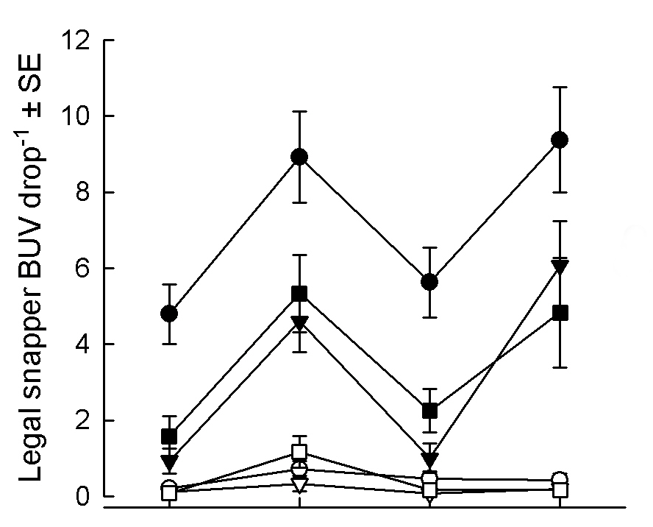

Fig. 3. Relative abundance of Snapper (Pagrus auratus) inside and outside three marine reserves in northeastern New Zealand. Data are for fish greater that mimimum legal size (270 mm) from 30 min deployments of Baited Underwater Video (BUV). Filled symbols: marine reserves, Open symbols: adjacent fished areas.  Leigh,  Hahei,  Tawharanui. (after Willis et al. 2003)

The R:NR ratio for legal sized P. auratus was similar among the three reserves at the time of the study, even though the youngest reserve was 6 years old and the oldest 23 years old. Snapper recovery therefore seems to be rapid, an impression confirmed by the increase in P. auratus numbers at the Poor Knights Islands Marine Reserve. The Poor Knights Islands were declared a partial marine reserve in 1981. A small proportion of the area was no-take but recreational fishing, using unweighted lines, was permitted in the majority of the reserve. In October 1998 the entire reserve reverted to "no-take". At that time there was a significant difference in legal P. auratus abundance between fully no-take areas of the Poor Knights and those areas with limited fishing, this difference was small in magnitude and likely to have been of limited ecological significance (Denny et al. 2002). After 3 years the number of legal-sized P. auratus had increased by 8.3 times relative to the pre-closure values (Fig. 4) and were 16.6 times more abundant than in fished reference areas, where numbers of legal sized P. auratus have remained static (Denny et al. 2002).

Fig. 4. Increase in relative abundance of Snapper population at the Poor Knights Marine Reserve relative to fished Reference areas. The entire Poor Knights Island Group was declared a no-take reserve in October 1998. Data are for fish greater that minimum legal size (270 mm) from 30 min deployments of Baited Underwater Video (BUV).  Poor Knights,  Cape Brett,  Mokohinaus. (after Denny et al. 2002).  = time of reserve creation.

Snapper populations at the Poor Knights Islands demonstrate that while rapid recovery is possible, it is only likely to occur under fully protected, no-take conditions. Similarly, the Mimiwhangata Marine Park (established 1984) on the coast adjacent to the Poor Knights, allows only recreational spearing or fishing using unweighted lines. Despite the exclusion of commercial fishing, the abundance of legal P. auratus at Mimiwhangata was not significantly different to reference areas outside the park. In fact, mean P. auratus numbers there were lower than at any other areas, despite the recreational gear limitations and the complete absence of commercial fishing (Denny and Babcock 2002).

The magnitude and speed of recovery of P. auratus populations in northeastern New Zealand can probably be ascribed to two factors. Firstly, individuals of this species can display a variety of behaviours, including seasonal onshore and offshore movements (Willis et al. 2003), as well as long-term residency within restricted areas (Willis et al. 2001). It is also likely that individuals switch from one behaviour to the other, and that they show intermediate types of behaviour. The seasonal migratory behaviour means that densities of legal P. auratus inside reserves vary by 3.9 times between spring (September) and autumn (April) as fish move on and offshore from coastal reefs (Fig. 3, Willis et al. 2003). A proportion of these fish take up residence on the reefs where they may remain in home range areas of less than 300 m diameter (Parsons et al. 2000) for periods of up to 3 years (Willis et al. 2001). In one case, a tagged P. auratus was seen 6 years after tagging, at less than I km from the tagging site (R. Babcock, unpublished data). Newly created reserves are therefore quickly stocked with migrating fish, some of which are likely to take up long term residence. The second reason for the ability of P. auratus populations in to recover is that there is a substantial stock of fish in northeastern New Zealand which provides not only migratory fish but also larval recruits (Gilbert et al. 2000). Reserves in other areas that once supported significant P. auratus populations, e.g. Tonga Island marine reserve in the northern South Island, do not appear to have shown a marked recovery in P. auratus populations (Cole et al. in press). The region once supported a substantial P. auratus fishery but this has been in serious decline since 1979 when the annual catch peaked at around 3203 tons and it now less than 200 t (Harley and Gilbert. 2000). The yield of the fishery in the Hauraki Gulf (northeastern New Zealand) has remained at over 5000 tons per annum since the 1940s. In the case of both P. auratus and J. edwardsii, the restoration of populations in marine reserves appears to have been facilitated by the presence of adjacent healthy populations.

Direct Effects on marine ecosystems: habitat recovery
“in taking an approach that wants to protect biodiversity, we’ll also ensure that fish stocks are there and the bio-mass is maintained” (S. Lee. The Dominion, February 7 2002)

The effects of fishing at the ecosystem level are now evident worldwide and extend far beyond the target species (Pauly et al. 1998). The direct effects of fishing, mainly trawling and dredging, on marine habitats are also widespread and pervasive and have been estimated to disturb areas of sea floor equivalent to the world’s continental shelf once every two years (Watling and Norse 1998). Three dimensional habitat structure is reduced or destroyed by these forms of fishing but no-take MPAs in locations such as the Georges Bank (northwest Atlantic) have enabled recovery of this habitat structure to occur (Collie et al. 1997). Species assemblage and habitat structure of soft bottom communities in northeastern New Zealand have also been linked to the intensity of trawling and dredging, using marine reserves as reference areas (Thrush et al. 1995, 1998). On Australia's northwest shelf, a ban on trawling has allowed sessile macrobenthos to recover. The increase in habitat forming species, such as gorgonians and ascidians, has been paralleled by an increase in the numbers of target fish species associated with them, such as tropical snappers and emperors (Lutjanidae, Lethrinidae; Sainsbury et al. 1998). Whether this was a direct result of the cessation of fishing, or an indirect effect of habitat structure, remains unclear. Only long-term and large-scale experiments will tell us conclusively whether changes in habitat structure affect the productivity of commercial species.

Displacement of fishing effort

“More marine reserves could force fishers into the remaining areas, depleting stock” (A. Macfarlane, New Zealand Herald, Feb. 4 2002.)

Some attempts to model marine reserves have concluded that no-take areas as large as 40-80% of the available habitat may be required in order to sustain fisheries yields (Sladek Nowlis and Roberts 1998), or ecosystem integrity (Sala et al. 2002). Other models show that if fishing effort remains constant while available fished area decreases the displacement of fishing effort by no-take areas could increase the impact of fishing on unprotected areas (Parrish 1999). Thus while some areas would be less impacted by fishing, the effects would increase proportionally in other areas.

Fig. 5. Exploitation rate in fished areas as a function of the proportion of the fished stock in marine reserves. The model assumes that total catch and effort remains constant and that the fished stock is evenly spread around all areas of coast. If this is so, the proportion of protected stock is proportional to the protected coastline, and in order to maintain catches, effort must go up in the remaining fished areas. (After Parrish 1999).

The problems foreshadowed by this model are of genuine concern, but their potential importance depends on several factors. Firstly, the proportion of coast set aside as marine reserve would have to be much larger than is seriously being proposed anywhere at present. In New Zealand, target proportions advocated by pro-reserve groups range from 10 - 20%, varying from one interest-group or political party to the next. At these levels of protection, the amount of effort displaced to other areas of coast will be relatively small (Fig. 5). The second condition would be the absence of effective fisheries management regimes outside protected areas. Proposals for systematic large-scale networks of marine reserves do not include dismantling existing management systems.

In the New Zealand context, a figure of 20% representation of coastal areas in MPAs is the highest proportion currently being proposed (Green Party 2002) and the Labour government supports a total of 10% (Department of Conservation 2002). This figure is well below that at which we would expect to see a rapid increase in displacement to unprotected areas. Furthermore, the current New Zealand Fisheries Act (1996) requires that fisheries are managed to ensure the protection of fisheries’ habitat as well as fished species. Consequently, fisheries management of non-reserve areas will need to account for and mitigate against undue pressure on fisheries and habitats as a result of any fishing displacement. The greater the proportion of marine reserve, the greater the need for managing human uses of non-reserve areas. To paraphrase the title of a frequently cited paper (Allison et al. 1998), while fisheries managers may not agree that marine reserves are necessary for marine conservation, they understand well that reserves alone will not be sufficient. Therefore, to raise the issue of displacement of fisheries effort as a major drawback of marine reserves requires us to adopt some unrealistic positions. This would include a simultaneous enhancement of management and conservation efforts within marine reserves, and a relaxation of these efforts in fisheries management.

Indirect Effects on marine habitats: environmental baselines
“Certainly they are great for science, to study the sea and the relationships between a range of animals on a long term basis” (J. Nicolson, New Zealand Herald, 31 January 2002).

Because of the pervasiveness and intensity of fishing activities, it has been suggested that marine reserves offer virtually the only way of understanding what a "natural" ecosystem might be like, or of appreciating the full impacts of fishing (Dayton et al. 1998). In addition to the physical damage caused by fishing, one obvious reason for this is that fishing may have directly reduced populations of some species to the point where they are no longer functionally-significant ecosystem components. Indirect effects of fishing on marine habitats are less obvious but are no less important. Marine reserves in northeastern New Zealand have provided important examples of such indirect effects and the importance of reserves as environmental baselines.

The first quantitative ecological descriptions of rocky reefs on the northeastern coast of New Zealand described extensive areas of urchin barrens, largely devoid of macroalgae and dominated by the grazing echinoid Evechinus chloroticus (Ayling 1978, Choat and Schiel 1982). Such barrens areas were extensive in no-take reserves, such as those at Leigh and Tawharanui, at the time of their establishment (1976 and 1982 respectively). By the 1990's, the extent of urchin barrens areas at Leigh was much smaller than it had been in the 1970's, and at both Leigh and Tawharanui reserves the proportion of reef occupied by barrens habitat was significantly lower inside than outside reserves (Babcock et al. 1999). Based on these comparisons, it was estimated that primary productivity of reefs might be as much as 58% greater on reefs inside the reserve than outside, due to the increase in biomass of brown algae such as Ecklonia radiata (Babcock et al. 1999). Densities of P. auratus and J. edwardsii inside both reserves were correspondingly higher than in fished areas, therefore one indirect effect of fishing was a trophic cascade in which densities of these predators controlled urchin densities and, indirectly, algal biomass and productivity (Fig. 6). Based on more conventional small-scale manipulative experiments (Andrew and Choat 1982, Andrew and MacDiarmid 1991, Steinberg et al. 1995), such a trophic cascade was thought not to exist in New Zealand.

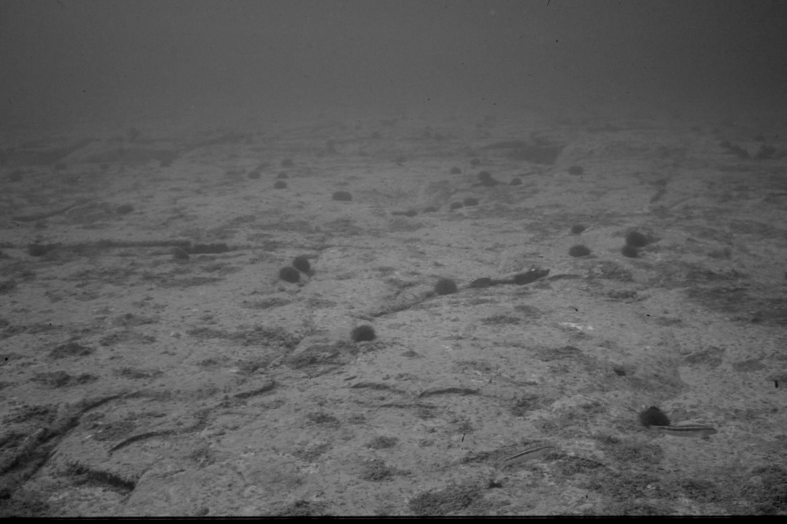
A)

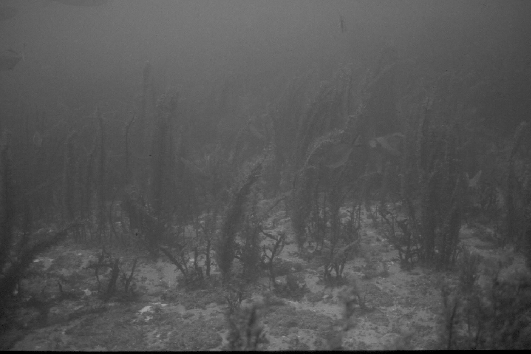
B)

Fig. 6. Habitat change at Leigh Marine Reserve. Trophic cascades resulting from the recovery of predator populations after fishing ceased led to a transition from urchin barrens dominated by Evechinus chloroticus (a) to mixed algal assemblages (b). Both photos are of the same site, at 5m, facing northwest from Martin’s Rock in 1993 (a), 2000 (b).

Urchin population structure and behaviour within the Leigh and Tawharanui reserves differed from that found in adjacent fished areas (Cole and Keuskamp 1998, Shears and Babcock 2002, 2003). More urchins adopted cryptic behaviour within reserves, sheltering among or beneath boulders. This was true even at sizes above the threshold (35-45 mm test diameter) at which they begin to graze openly on the substratum in fished areas. Populations in reserves tended to be bi-modal, with 35-45 mm size classes poorly represented, presumably due to predation. Tethering experiments showed that small urchins were most vulnerable to predation and confirmed that predation was higher inside reserves and that at least 45% of urchin mortality was attributable to J. edwardsii (Shears and Babcock 2002). One consequence of changes in urchin behaviour and size-specific predation may be a significant time lag in the manifestation of trophic cascade effects. Decreases in urchin density and habitat transitions from barrens to kelp or algal turf were still being recorded in the Leigh reserve as recently as 2000 (Shears and Babcock 2003). These changes in habitat may in turn have indirect effects on the abundance of other organisms. For example, the density of the limpet Cellana stellifera is lower inside reserves while the density of the turban shell Cookia sulcata is higher (Shears and Babcock 2003). Experimental habitat manipulations have shown that Cellana grows and survives better in the presence of Evechinus, while the reverse is true of Cookia (Andrew and Choat 1982).

Marine reserves in New Zealand have demonstrated their potential to act as environmental baselines and ecological tools, and have enabled insights to be made into the management, productivity and ecological function of coastal ecosystems that would not otherwise have been possible. More insights are likely to be obtained from the range of more recently created marine reserves in other parts of the New Zealand, as well as Australia. These may take some time to appear if timelags, such as those seen for trophic cascade effects in northeastern New Zealand, are involved. Systems in areas where urchin barrens are present, such as the northern South Island, and the NSW coast (Andrew and O’Neill 2000), are likely to respond with trophic cascades similar to those seen at Leigh and Tawharanui. However, there are indications that not all systems will respond in this way. For example macroalgae, not urchin barrens, dominate habitats around the majority of the New Zealand coastline (Choat and Schiel 1982) and much of temperate Australia (Prince 1995, Fowler Walker and Connell 2002, Edgar and Barrett 1997).

Effects on fishing: lock-up or spillover?
“the international evidence of increases of stocks in fisheries next to established marine reserves remains indisputable” (S. Lee, The Dominion, Feb. 7 2002)

“What I am condemning is the objective of locking up a vast amount of perfectly good ocean in marine reserves for all time…The kaftan wearers may shout “what about spillover”, but paua [abalone] don’t spillover” (E. Arron, Dive NZ June/July 2002)

“If the government is successful in locking up 10 percent of New Zealand’s fishing grounds there will be significant implications for commercial, customary [maori] and recreational fishers”. (N. Gibbs, New Zealand Herald, Jan. 31, 2002)

No other concept associated with marine reserves is more controversial than that of "spillover". Spillover implies that fish may move out of a protected area due to density-dependent effects, once the area approaches carrying capacity (Kramer and Chapman 1999). The use of this term has broadened to include any movement across a reserve boundary. Since reserves do not physically fence in fish, cross boundary movements are inevitable. Unfortunately, little is known about the scale of these movements. Because the opposing claims of those who support or oppose marine reserves hinges on this knowledge, many apparently contradictory claims can be found in the scientific literature as well as in popular media. Fishing interests generally hold the position that reserves will "lock up" fish resources, implying that fish will not cross reserve boundaries and that they will not be available to the fishery (Te Ohu Kai Moana 2001). This is often accompanied by claims that reserves will not protect fish populations because fish move too widely (Option4 2002). Proponents of marine reserves claim that cross boundary movements of fish (presumably combined with a longer period of growth while protected) will result in enhanced fisheries yields at some scale (Roberts et al. 2001). Given the diversity of fish species and their diverse life histories, generalisations are unwise, but this does not seem to have tempered the statements of either side. While little evidence exists to support either claim, the facts that do exist tend to support the idea that reserves will enhance yields (Russ and Alcala 1996, Roberts et al. 2001). Even so, much of this evidence has been questioned because of concerns about replication or other design aspects of the studies (Hillborn 2002).

Evidence from New Zealand indicates that while reserves do not lock up resources, neither do they enhance fisheries yields (Fig. 7). Rather it seems that, as far as can be measured, the effects of reserves on local fisheries yields are neutral. A three-year study of a lobster fishery in the Leigh region compared Catch Per Unit Effort (CPUE) and value of catch around the boundary of the Leigh marine reserve with those of two other areas in the region, Coastal Leigh and Little Barrier Island. Overall, both CPUE and value of catch were the same around the Leigh reserve boundary as they were at the two other areas (Kelly et al. 2002). This was an unexpected result since fishing adjacent to the reserve took place at the seaward boundary, 800 m offshore. This is an area of sandy bottom up to 700 m from the coastal reefs where J. edwardsii makes its dens, and where fishers usually set their traps.

Fig. 7. Lobster catch around Leigh Marine Reserve. CPUE from three years of fishing on the offshore boundary of the Leigh Marine Reserve and on adjacent coastlines. CPUE at each site varied from year to year but overall did not differ among the sites adjacent to the reserve and non-reserve sites. (after Kelly et al. 2002).

Fishing along the offshore reserve boundary began around 1985, when the reserve was nine years old. Fishers target the offshore boundaries of the reserve during the seasonal movements of J. edwardsii when they travel away from reefs onto the adjacent sand flats. The reasons for these movements are not entirely clear but they are associated with periods of increased feeding activity (Kelly et al. 1999). Jasus edwardsii can travel for several kilometers during these movements that may last for weeks. When Spiny Lobster return to the reef it is usually to the same part of the coastal reef they occupied previously and some individuals have been tracked back to the same den at which they were originally tagged (Kelly 2001). This combination of site fidelity and movement over scales similar to the dimensions of the reserve has resulted in a situation in which J. edwardsii populations are afforded a substantial degree of protection while still making a significant contribution to local commercial catches.

The marine reserve at Leigh has protected the resident J. edwardsii population, but it has not locked it up, contrary to claims of some reserve opponents. However, study of the J. edwardsii fishery at Leigh has shown that one of the claims of marine reserve advocates, that marine reserves increase yields, may be exaggerated. Yields of J. edwardsii are no higher adjacent to the reserve than they are at other comparable sites in the region. Overall, the fact that a positive conservation outcome has been achieved without detriment to the commercial fishery would seem to be a desirable result. While no direct measures have been made of the influence of marine reserves on catches of New Zealand fish species, at least one of them, P. auratus, has characteristics similar to J. edwardsii that may result in a similar balance of conservation combined with a contribution to fisheries.

A high level of site-fidelity is shown by some snapper, with home ranges in the order of less than 300 m radius as demonstrated using visible and acoustic tags (O'Dor et al. 2001, Willis et al. 2001). A proportion of individuals show a wider ranging behaviour, and acoustic tracking in the Leigh reserve has shown that they may range over distances of more than 1 km (Egli and Babcock 2002). Some of these tracked fish have left the reserve for periods of up to several weeks before returning. This behaviour, combined with the seasonal movement patterns of P. auratus (Crossland 1976), indicates that in addition to the conservation benefits derived from reserves, there is a clear potential for fish that have spent some time in a reserve to re-enter the fishery. Similar conclusions have been drawn for Blue Cod Parapercis colias based on a mark-recapture study in central New Zealand (Cole et al. 2000).

A spatially explicit model of the Hauraki Gulf Snapper fishery, incorporating movements of both fish and fishers, suggests that even with 50% of the area set aside in no-take areas, there would be virtually no impact on the yield of the fishery. Under the various scenarios explored, the influence of no-take areas on catch rates might be either positive or negative (Bentley et al. unpublished), but the magnitude of any effects was predicted to be small in relation to the overall catch. This is in agreement with the empirically derived conclusions of Kelly et al. (2002) in their small-scale study of the J. edwardsii fishery around Leigh.

Egg and larval export
“marine reserves will boost fisher’s catch rates by giving fish a safe place to spawn and rebuild their flagging numbers” (S. Lee The Dominion, Feb. 7 2002)

The potential for marine reserves to contribute disproportionately large amounts of egg production is an idea widely promoted as a way that marine reserves can benefit the stock outside of reserves (Roberts 1997). Since eggs and ultimately larvae are likely to be transported out of any reserve, even though some may be retained (Jones et al.1999), protected populations in reserves may help maintain recruitment at larger scales. There is clear evidence that areas of coastline protecting populations of commercially exploited species do indeed contribute disproportionately to egg production. Because both numbers and size of protected species increase because of protection, there is also an increase in the biomass of protected species, and egg production is proportional to biomass.

For P. auratus, egg production inside reserves is estimated to be 18 times greater inside than outside reserves, based on a study of three reserves over three years (Willis et al. 2003). Similar results have been demonstrated for J. edwardsii in northeastern New Zealand, with egg production increasing at 6.7% per year (Kelly et al. 2000). After 25 years, this rate of increase would equate to egg production 4.4 times greater inside than outside reserves (Kelly et al. 2000). In the case of P. auratus, these differences mean that a reserve covering approximately 5 km of coastline (similar to the marine reserve at Leigh) would produce a number of eggs or larvae equivalent to 90 km of coastline (Willis et al. 2003). For J. edwardsii, the equivalent length of coast could be from 22 km (Kelly et al. 2000) to 80 km (MacDiarmid and Breen 1992) depending on when the estimate was made. In principle, the relatively small no-take reserves have the potential to sustain recruitment in much larger portions of the coast.

Stock-recruitment relationships in fished species are notoriously weak. Some fisheries scientists argue that, because of this, it is unlikely that any contribution from reserves to overall recruitment would be undetectable against the background of environmentally determined recruitment variability. Indeed, variations in seawater temperature explain 94% of annual recruitment variation for P. auratus in the Hauraki Gulf (Francis 1993). One of the largest Marine Protected Areas in US waters covers 17,162 km² (<30%) of the Georges Banks and it has achieved a marked recovery of scallop stocks (Murawski et al. 2000). Scallop biomass is 9 times greater in the closed areas than in trawled areas; therefore we should also expect the egg production to be proportionately larger. Despite this, in the 5 years since protection, there has been no statistically significant increase in recruitment levels on areas of the continental shelf adjacent to the protected area (D. Hart, personal communication). Therefore, while there is good evidence that reserves enhance egg production and that recruitment should be enhanced, it will be difficult to actually show that this translates into improved recruitment. In the case of the Georges Banks, longer time-series of data may be required. Elsewhere much larger areas of marine reserves will be needed to achieve increases of larval abundance on a scale that could be expected to show measurable results. The current proportion of marine reserves along the New Zealand coastline is less than 0.1%, just a drop in the ocean when it comes to influencing recruitment. While no evidence for such increases currently exists from marine reserves, stock-recruitment relationships have been shown in some invertebrate populations based on experimental manipulations at spatial scales (~ 1km) similar to most marine reserves (Prince et al. 1988).

Larval export is an important issue that requires more satisfactory resolution both for conservation and the management of fisheries. In this regard, a consistent application of ecological assumptions is desirable. While fisheries scientists are correct to point out the weakness of stock recruitment relationships, the models of fish population dynamics on which most of their management strategies are based depend either implicitly or explicitly on the existence of the stock-recruitment relationship (Jennings et al. 2001). New Zealand’s Fisheries Act (1996) requires fisheries to be managed so that they achieve “Biomass at Maximum Sustainable Yield” or B_{msy} , a concept that is explicitly founded on the stock-recruitment relationship. It is inconsistent to deny the potential usefulness of reserves as a source of recruits while simultaneously basing "traditional" fisheries management decisions on models that rely on the stock-recruitment relationship.

Fig. 8. Recruitment and minimum levels of reserve protection. The logistic population growth curve a) in which fastest growth is achieved when the population is at about half of its maximum level (B_{max}) is the basis for the principle of maximum sustainable yield (MSY). At higher levels of biomass population growth slows due to density dependent effects on the survivorship or growth of recruits. The New Zealand Fisheries Act 1996 requires fisheries to be managed so that they are at the B_{MSY} level b), forming the basis of setting TAC in all quota management species. In a population harvested down to B_{msy}, approximately 50% of the original spawning potential (egg production) of the population would remain, but reduced egg production is expected to be compensated for by a two-fold increase in egg survival due to release from density dependent effects c). Reducing the population to smaller and smaller fractions of its spawning potential, requires a corresponding increase in egg survival in order to maintain the original spawning potential and sustainable harvest. At levels at or below 20% of spawning potential the increases in egg survival required begin to exceed those that might be realistically expected (i.e. 5 – 10 fold increases). It has been argued by Bohnsack (2003) that protecting at least 20% of a species’ habitat in reserves will provide insurance that at least that much of the spawning potential remains.

The idea that marine reserves may provide insurance against recruitment overfishing in the wider stock has been used (retrospectively) as the basis for justifying the proportion of coastline that should be protected. Bohnsack (2003) has suggested that proportions of between 10-20 % protection are prudent because protection of smaller proportions of the coast requires unrealistically large compensatory increases in larval survival under overfishing conditions in unprotected areas (Fig. 8).

Reserves as management tools: insuring against the unexpected

“The (Fisheries) act has got all the tools to manage them (fisheries) in a much more sophisticated and targeted way than the Marine Reserves Act, which is a totally blunt instrument” (N. Gibbs The Dominion, Feb. 7 2002)

“The fatal flaw…is the experience of the QMS (quota management system). Over the past 17 years we’ve trashed a whole range of fish stocks” (B. Weeber The Dominion, Feb. 7 2002)

New Zealand was one of the first countries to implement an output- or quota-based fisheries management system for all major commercial species. In this approach the amount of fish that can be caught sustainably in any area is determined and then used as the basis for setting the quota. The Quota Management System has been praised by analysts, both within New Zealand and overseas, as a model of how fisheries should be managed since one of its major results has been an end to the “race for fish” (Dewees 1998). There is no doubt that the QMS is an improvement on previous systems that tried to control harvest levels by limiting the number of fishers, types of gear or fishing seasons. It is argued by some that with a cap on the total amount of fish that can be taken, there is no need for marine reserves as a means of managing fish populations. Setting aside concerns relating to habitat destruction and indirect effects of fishing, there is some validity to this line of argument however it hinges on the crucial assumption that the quota level is in fact set at the right level.

As has been the case with all other attempts to manage fisheries, it is becoming apparent that we do not always have perfect knowledge of fish stocks that will allow us to set quotas correctly. Even with New Zealand's QMS, some stocks in some areas have been declining through the 1990's e.g. Stewart Island and Catlins Paua Haliotis iris (Andrew et al. 2002), Fiordland J. edwardsii (Starr et al. 1997), and Blue Cod in the northern South Island (Ministry of Fisheries 2003). Even for the P. auratus fishery in northeastern New Zealand (SNA1), major uncertainties remain surrounding total catch estimates (Boyd and Riley 2002). The P. auratus fishery in SNA1 is one of the most commercially and recreationally important inshore fisheries in New Zealand. It is also one of the best studied, yet despite this it has recently become apparent that the total P. auratus catch exceeds the total allowable catch (TAC) by 40% or over 3000 tons (Table 2). This uncertainty has major implications for the setting of TAC. Economic, demographic and technological trends indicate that the level of recreational fishing is likely to continue to grow. Given the difficulty of controlling and monitoring recreational fishing, marine reserves are likely to provide an important level of insurance against this uncertainty. They also provide a significant resource for those recreational users of the marine environment who wish to enjoy their fish alive, and in their natural habitat. Tourism based on the marine reserve at Leigh alone is estimated to bring 100,000 visitors per year, contributing substantially to the local economy (Cocklin et al. 1998).

 | TACC | Commercial Landings | Recreational Catch | TAC | Total Landings
1996 | 4,938 | 5,049 | 2,322 | † | 7,371
1997 | 4,500 | 4,519 | 2,322* | 7,550 | 6,841*
1999 | 4,500 | 4,411 | 2,322* | 7,550 | 6,733*
2000 | 4,500 | † | 6,200 | 7,550 | 10,700

Table 2. Snapper fishery in northeastern New Zealand (SNA1). Data (tons) are taken from Gilbert et al. (2000) except for estimates of recreational catch in 2000 (Boyd and Riley 2003). TAC = total allowable catch, TACC = total allowable commercial catch. * estimated based on most recent previous estimate. † not available at the time of publication.

Conclusion: Reserves as tools for science and management
Fisheries management is broader than fisheries yield enhancement, or even maintenance. This is a distinction that those debating marine reserves frequently fail to make. Increasingly, modern fisheries legislation, including the New Zealand Fisheries Act (1996) requires that not only fish stocks, but also essential fish habitat, be managed sustainably. In order to achieve this, complex interactions must be accounted for e.g. habitat protection, by-catch species and changes in population structure. Given the difficulty of modeling even one stock accurately, marine reserves are probably the best way to achieve the goals of conservation, ecosystem management and verifiably sustainable fisheries. Given the less-than-perfect track record of even our best fisheries management systems, marine reserves are an option that must be implemented. Evidence from New Zealand suggests that their impacts on fishers and fishery economics are at worst neutral, but that they also bring many benefits in terms of protecting habitat and populations of exploited species. Reserves must be used in combination with other management systems to achieve overall protection of marine resources. For example, reserves may displace fishing effort, which may have undesired effects on fished areas especially where fishing overcapacity exists. Even though the level of impact is likely to be minor if less than 20% of habitat is protected, population growth and increasing access to marine environments mean that, even with reserves, pressure on fish stocks and the marine environment will increase. Without a range of other management tools (e.g. QMS) reserves may introduce a false sense of security and exacerbate problems elsewhere. As with anything new, there is a certain level of fear and ignorance surrounding marine reserves. With time, it is likely to become more and more apparent that we have nothing to lose and everything to gain from including marine reserves as one of a range of essential management tools for the marine environment.

References.
Adams, S., Mapstone, B.D., Russ, G.R. and Davies, C.R. 2000. Geographic variation in the sex ratio, sex specific size, and age structure of Plectropomus leopardus (Serranidae) between reefs open and closed to fishing on the Great Barrier Reef. Canadian Journal of Fisheries and Aquatic Sciences. 57:1448-1458.
Allison, G.W., Lubchenco, J. and Carr, M.H. 1998. Marine reserves are necessary but not sufficient for marine conservation. Ecological Applications 8 (Suppl.):79-92.
Andrew, N.L. and Choat, J.H. 1982. The influence of predation and conspecific adults on the abundance of juvenile Evechinus chloroticus (Echinoidea: Echinodermata) Oecologia 54:80-87.
Andrew, N.L. and MacDiarmid, A.B. 1991. Interrelations between sea urchins and spiny lobsters in northeastern New Zealand. Marine Ecology Progress Series 70:211-222
Andrew, N.L. and O’Neill, A.L. 2000. Large-scale patterns in habitat structure on subtidal rocky reefs in New South Wales. Marine and Freshwater Research. 51:255-263.
Andrew, N.L., Naylor, J.R. and Kim, S.W. 2002. Fishery independent surveys of the relative abundance and size-structure of paua (Haliotis iris) in Pau 5B and PAU 5D. New Zealand Fisheries Assessment Report 2002/41. 24 p. Ministry of Fisheries, Wellington.
Ayling, A.M. 1978. Okakari Point to Cape Rodney Marine Reserve Survey. 98 p. Leigh Marine Laboratory Bulletin 1. University of Auckland, Leigh.
Babcock, R.C., Kelly, S., Shears, N.T., Walker, J.W. and Willis, T.J. 1999. Large-scale habitat change in a temperate marine reserve. Marine Ecology Progress Series 189:125-134.
Bentley, N., McNeill, S.E., Davies, N.M. and Davies C.R. 2001. An example of assessing spatial closures as a fisheries management tool. 12 p. Draft Report to the New Zealand Ministry of Fisheries.
Bohnsack, J.A. 1997. Consensus development and the use of marine reserves in the Florida Keys, USA. p. 1927-1930. 8th International Coral Reef Symposium, Panama. edited by H.A. Lessios and I.G. Macintyre. Vol 2.
Bohnsack, J.A., Causey, B., Crosby, M.P., Griffis, R.B., Hixon, M.A., Hourigan, T.F., Koltes, K.H., Maragos, J.E., Simons, A. and Tilmant, J.T. 2003. A rationale for minimum 20-30% no take protection. 9th International Coral Reef Symposium, Bali. edited by Kasim Moosa, M.K, et al. Bali Indonesia. in press.
Boyd, R.O. and Reilly, J.L. 2002. 1999/2000 national marine recreational fishing survey: harvest estimates. Draft New Zealand Fisheries Assessment Report. 28 p. Ministry of Fisheries, Wellington.
Choat, J.H and Schiel, D.R. 1982. Patterns of distribution and abundance of large brown algae and invertebrate herbivores in subtidal regions of northern New Zealand. Journal of Experimental Marine Biology and Ecology. 60:129-162.
Cocklin, C., Craw, M. and McAuley, I. 1998. Marine reserves in New Zealand: use rights, public attitudes and social impacts. Coastal Management 26:213-231.
Cole, R.G. 1994. Abundance, size structure, and diver-oriented behaviour of three large benthic carnivorous fishes in a marine reserve in northeastern New Zealand. Biological Conservation 70:93-99.
Cole, R.G. and Keuskamp, D. 1998. Indirect effects of protection from exploitation: patterns from populations of Evechinus chloroticus (Echinoidea) in northeastern New Zealand. Marine Ecology Progress Series. 173:215-226
Cole, R.G., Villouta E. and Davidson, R.J. 2000. Direct evidence of limited dispersal of the reef fish Parapercis colias (Pinguipedidae) within a marine reserve and adjacent fished areas. Aquatic Conservation: Marine and Freshwater Ecosystems.10:421-436.
Cole, R.G., Syms, C., Alcock, N.K., Notman, P., Stewart, R. and Carr, M.H. in press. Sampling abundance and size of temperate reef fishes in marine reserves: a methodological comparison of open circuit scuba, semi-closed rebreathers and baited video.
Collie, J.S., Escanero, G.A. and Valentine, P.C. 1997. Effects of bottom fishing on benthic megafauna of Georges Bank. Marine Ecology Progress Series. 155:159-172.
Crossland, J. 1976. Snapper tagging in North-East New Zealand, 1974: Analysis of methods, return rates, and movements. New Zealand Journal of Marine and Freshwater Research. 10:675-686.
Davidson, R.J., Villouta, E. Cole, R.G. and Barrier, R.G.F. 2002. Effects of marine reserve protection on spiny lobster (Jasus edwardsii) abundance and size at Tonga Island marine reserve, New Zealand. Aquatic Conservation: Marine and Freshwater Ecosystems. 12:213-227.
Dayton, P.K., Tegner, M.J., Edwards, P.B. and Kristin L. Riser. 1998. Sliding baselines, ghosts, and reduced expectations in kelp forest communities. Ecological Applications 8:309-322.
Denny, C., Babcock, R. 2002. 'Fish survey of the Mimiwhangata Marine Park, Northland'. Report to the Department of Conservation. 28 pp.
Denny, C., Willis, T.J. and Babcock, R.C. 2002. Effects of Poor Knights Islands marine reserve on demersal fish populations. 57 p. Report to the Department of Conservation.

Department of Conservation, 2002. Marine Reserves Bill Has First Reading. http://www.doc.govt.nz/whats-new/presult.asp?prID=884
Dewees, C.M. 1998. Effects of individual quota systems on New Zealand and British Columbia fisheries. Ecological Applications. 8 (Suppl.):133-138.
Edgar, G.J. and Barrett, N.S. 1997. Short term monitoring of biotic change in Tasmanian marine reserves. Journal of Experimental Marine Biology and Ecology 213:261-279.
Edgar, G.J. and Barrett, N.S. 1999. Effects of the declaration of marine reserves on Tasmanian reef fishes, invertebrates and plants Journal of Experimental Marine Biology and Ecology 242:107-144.
Egli, D.P., and Babcock R.C. 2002. Optimising marine reserve design in New Zealand – Part I: Behavioural data for individual based models. 39 p. Report to the Department of Conservation, Northland Conservancy
Fowler Walker, M. and Connell, S.D. 2002. Opposing states of subtidal habitat across temperate Australia: consistency and predictability in kelp canopy-benthic associations. Marine Ecology Progress Series 240:49-56
Francis, M.P. 1993. Does water temperature determine year class strength in New Zealand snapper (Pagrus auratus, Sparidae)? Fisheries Oceanography 2:65-72.:
Francour, P., Harmelin, J.-G., Pollard, D., Sartoretto, S., 2001. A review of marine protected areas in the northwestern Mediterranean region: siting, usage, zonation and management. Aquatic Conservation: Marine and Freshwater Ecosystems 11, 155-188.
Freeman, D.J. and Duffy, C.A.J. 2003. Te Angiangi marine reserve: reef fish and rock lobster monitoring 1995-2001. Department of Conservation, East Coast Hawke’s Bay Conservancy.
Gilbert, D.J., McKenzie, J.R., Davies, N.M. and Field, K.D. 2000. Assessment of the SNA 1 stocks for the 1999-2000 fishing year. New Zealand Fisheries Assessment Report 2002/38. 52 p. Ministry of Fisheries, Wellington.

Green Party, 2002. Greens want more marine reserves. http://onenews.nzoom.com/onenews_detail/0,1227,100795-1-8,00.html
Harley, S.J. and Gilbert, D.J. 2000. Assessment of the Tasman and Golden Bays snapper fishery for the 1999-2000 fishing year. New Zealand Fisheries Assessment Report 2002/28. 42 p. Ministry of Fisheries, Wellington.
Hillborn, R. 2002. Marine reserves and fishery management. Science 295:1233-1234.
Jennings, S., Kaiser, M.J. and Reynolds, J.D. 2001. Marine Fisheries Ecology. 417 p. Blackwell Science Oxford
Jones, G.P., Cole, R.C. and Battershill, C.N. 1992. Marine reserves: do they work? pp. 29-45. in Proceedings of the Second International Temperate Reef Symposium edited by C.N. Battershill et al. NIWA, Wellington.
Jones, G.P., Milicich, M.J. Emslie, M.J.and Lunow, C. 1999. Self-recruitment in a coral reef fish population Nature 402:802-804.
Kelly, S. 1999. 1999 Lobster survey of Te Awaatu (The Gut) marine reserve, Doubtful Sound. 12 p. Report to the Department of Conservation.
Kelly, S. 2000. 2000 Lobster survey of the Cathedral Cove (Te Whanganui A Hei) marine reserve. 15 p. Report to the Department of Conservation.
Kelly, S., 2001. Temporal variation in the movement of the spiny lobster Jasus edwardsii. Marine and Freshwater Research 52:323-331.
Kelly, S., MacDiarmid, A.B., and Babcock, R.C., 1999. Characteristics of spiny lobster, Jasus edwardsii, aggregations in exposed reef and sandy areas. Marine and Freshwater Research 50:409-416
Kelly, S., Scott, D., MacDiarmid, A.B. and Babcock, R.C., 2000. Spiny lobster, Jasus edwardsii, recovery in New Zealand marine reserves. Biological Conservation 92:359-369.
Kelly, S. and Haggitt, T. 2002. Cape Rodney to Okakari Point marine reserve lobster monitoring program: May 2002 Survey. 25 p. Report to the Department of Conservation.
Kelly, S., Scott, D. and MacDiarmid, A.B. 2002. The value of a spillover fishery for spiny lobsters around a marine reserve in northern New Zealand. Coastal Management 30:153-166.
Kramer, D.L. and Chapman, M.R. 1999. Implications of fish home range size and relocation for marine reserve function. Environmental Biology of Fishes 55:65-79.
Lauck, T., Clark, C.W., Mangel, M. and Munro, G.R. 1998. Implementing the precautionary principle in fisheries management through marine reserves. Ecological Applications 8 (Suppl.):72-78.
Lough, P. 2002. Editorial Comment. Seafood New Zealand September:1-2
Ministry of Fisheries. 2003. Blue Cod 7 Consultation. 24 p. http://www.mfish.govt.nz/current/blue-cod/index.html. New Zealand Ministry of fisheries, Wellington.
MacDiarmid, A.B. and Breen, P.A. 1982. Spiny lobster population change in a marine reserve. pp. 47-56. in Proceedings of the Second International Temperate Reef Symposium edited by C.N. Battershill et al. NIWA, Wellington.
Murawski, S.A., Brown, R. Lai, H.L. Rago, P.J. and Hendrikson, L. 2000. Large-scale closed areas as a fishery management tool in temperate marine systems: the Georges Bank experience. Bulletin of Marine Science. 66:775-798.
New Zealand Fishing Council. 2001. Opposition to marine reserve call. http://onenews.nzoom.com/onenews_detail/0,1227,70663-1-7,00.html
O'Dor, R.K., Aitken, J.P., Babcock, R.C., Bolden, S.K., Seino, S., Zeller, D.C., and Jackson, G.D. 2001. Using radio-acoustic positioning and telemetry (RAPT) to define and assess marine protected areas (MPAs). in: Electronic tagging and tracking in marine fisheries Methods and Technologies in Fish Biology and Fisheries, Vol 1, edited by J. Sibert and J. Nielsen. Kluwer Academic Press, Dordrecht.
Option4. 2002. What does option4 stand for? http://option4.co.nz/whatdoes.htm
Parrish, R. 1999. Marine reserves for fishery management: why not. California Cooperative Oceanic and Fisheries Investigations 40:77-86.
Parsons, D., Babcock, R., Willis, T. 2000. 'Space utilization characteristics of snapper (Pagrus auratus) in a marine reserve.' Report to the Department of Conservation. 31 pp.
Pauly, D., Christensen, V., Dalsgaard, J., Froese, R. and Torres, F. Jr. 1998. Fishing down marine food webs. Science 279: 60-863.
Prince, J. 1995. Limited effects of the sea urchin Echinometra matthaei (de Blainville) on the recruitment of benthic algae and macroinvertebrates into intertidal rock platforms at Rottnest Island, Western Australia. Journal of Experimental Marine Biology and Ecology. 186:237-258.
Prince, J.D., Sellers, T.L., Ford, W.B. and Talbot S.R. 1988. Confirmation of a relationship between the localized abundance of breeding stock and recruitment for Haliotis rubra (Mollusca: Gastropoda). Journal of Experimental Marine Biology and Ecology. 1988.122:17-24.
Roberts, C.M. 1997. Ecological advice for the global fisheries crisis. Trends in Ecology and Evolution 12:35-38.
Roberts, C.H. and Hawkins, J.P. 2000. Fully protected marine reserves: a guide. 131 p. WWF Endangered Seas Campaign, Washington DC
Roberts, C.M., Bohnsack, J.A., Gell, F.,. and Goodridge, R. 2001. Effects of marine reserves on adjacent fisheries. Science 294:1920-1923.
Roughgarden, J. 1998. How to manage fisheries. Ecological Applications. 8:160-164.
Russ, G.R. and Alcala, A.C. 1996. Do marine reserves export adult fish biomass? Evidence from Apo Island, central Philippines. Marine Ecology Progress Series 132:1-9.
Sala, E., Aburto-Oropeza, O., Paredes, G., Parra, I., Barrera, J.C. and Dayton, P.K. 2002. A General Model for designing networks of marine reserves. Science 298:1991-1993.
Schmidt, K.F. 1997. ‘No-take’ zones spark fisheries debate. Science, 277:489-491.
Shears, N.T. and Babcock, R.C. 2002. Marine reserves demonstrate top-down control of community structure on temperate reefs. Oecologia. 132:131-142.
Shears, N.T. and Babcock, R.C. 2003. Continuing trophic cascade effects after 25 years of no-take marine reserve protection. Marine Ecology Progress Series 246:1-16.
Sladek Nowlis, J. and Roberts, C.M. 1999. Fisheries benefits and optimal design of marine reserves. Fishery Bulletin 97:604-616.
Starr, P.J., Breen, P.A., Hilborn, R.H. and Kendrick, T.H. 1997. Evaluation of a management decision rule for a New Zealand rock lobster substock. Marine and Freshwater Research. 48:1093-1101.
Steinberg, P.D., Estes, J.A. and Winter, F.C. 1995. Evolutionary consequences of food chain length in kelp forest communities. Proceedings of the National Academy of Science USA. 92:8145-8148
Te Ohu Kai Moana. 2001. Marine reserves need to be put on hold. http://www.tokm.co.press/10-12-01_Marine_reserves_need_to_be_put_on_hold.htm
Thrush, S.F. Hewitt, J.E. Cummings, V.J. Dayton, P.K 1995. The impact of habitat disturbance by scallop dredging on marine benthic communities: What can be predicted from the results of experiments. Marine Ecology Progress Series. 129:141-150.
Thrush, S.F., Hewitt, J.E., Cummings, V.J., Dayton, P.K., Cryer, M., Turner, S.J., Funnell, G.A., Budd, R.G., Milburn, C.J. and Wilkinson, M.R 1998. Disturbance of the marine benthic habitat by commercial fishing: Impacts at the scale of the fishery. Ecological Applications. 8:866-879.
Turpie, J.K., Beckley, L.E. and Katua, S.M. 2000. Biogeography and the selection of priority areas for conservation of South African coastal fishes. Biological Conservation. 92:59-72.
Watling, L. and Norse, E.A. 1998. Disturbance of the seabed by mobile fishing gear: A comparison to forest clearing. Conservation Biology 12:1180-1197.
Willis, T.J. and Babcock, R.C. 2000. A baited underwater video system for the determination of relative density of carnivorous reef fish. Marine and Freshwater Research 51:755-763.
Willis, T.J., Millar, R.B. and Babcock, R.C. 2000. Detection of spatial variability in relative density of fishes: comparison of visual census, angling, and baited underwater video. Marine Ecology Progress Series 198:249-260.
Willis, T.J., Parsons, D.M. and Babcock, R.C. 2001. Evidence for site fidelity of snapper (Pagrus auratus) within a marine reserve. New Zealand Journal of Marine and Freshwater Research 35:581-590.
Willis, T.J., Millar, R.B. and Babcock, R.C. 2003. in press Protection of exploited fishes in temperate regions: high density and biomass of snapper Pagrus auratus (Sparidae) in northern New Zealand marine reserves. Journal of Applied Ecology 40:

